**U.S Alzheimer’s Therapeutic Market**

**By Therapeutic approach** (Symptomatic Treatments, Disease-modifying therapies (DMTs)), **By Drug Class** (Cholinesterase inhibitors, NMDA Receptor Antagonists, Monoclonal Antibodies, Combination Drugs, Pipeline Drugs) **By Stage of Disease (**Early-stage (Mild Cognitive Impairment), Mild to Moderate Alzheimer’s, Severe Alzheimer’s) **By Distribution Channel** (Hospital Pharmacy, Retail Pharmacy, E-commerce, Drug Store) **And by Region/Country**. Global and Regional Industry Overview, Market Intelligence, Comprehensive Analysis, Historical Data, and Forecasts 2024 – 2032

According to Intelli, the U.S Alzheimer’s Therapeutic Market size was valued at USD 5,250.5 Million in 2024 and is projected to reach USD 20,854.15 Million by 2032, growing at a compound annual growth rate (CAGR) of 19.32% during the forecast period of 2024 to 2032.

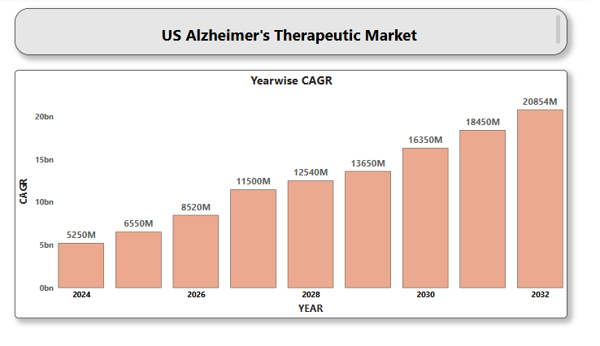

**U.S. Biochip Market**

**By Product Type** (DNA Chips, Protein Chips, Lab-on-chip) **By** **Technology** (Microarray Technology, Microfluidics, Nanotechnology-based Biochips), **By** **End-User** (Hospitals & Diagnostic Centers, Pharmaceutical & Biotechnology Companies, Academic & Research Institutes, Contract Research Organizations (CROs)) **And by Region/Country**. Global and Regional Industry Overview, Market Intelligence, Comprehensive Analysis, Historical Data, and Forecasts 2024 – 2032

According to Intelli, the U.S. Biochip Market size was valued at USD 5,281.32 Million in 2024 and is projected to reach USD 12,360.41 million by 2032, growing at a compound annual growth rate (CAGR) of 11.74% during the forecast period of 2024 to 2032.

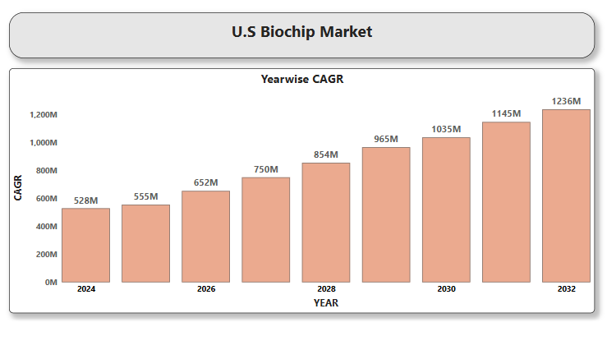

**U.S. Cuffless Blood Pressure Monitor Market**

**By** **Device type** (Wrist-Based Monitors, Finger-Based Monitors, Patch-Based and Wearable Monitors), **By** **End-user** (Home Healthcare, Hospitals, Clinics, Ambulatory Surgical Centers), **By** **Distribution Channel** (Online Retail, Pharmacies & Drug Stores) **And by Region/Country**. Global and Regional Industry Overview, Market Intelligence, Comprehensive Analysis, Historical Data, and Forecasts 2024 – 2032

According to Intelli, the U.S. Cuffless Blood Pressure Monitor Market Size was valued at USD 211.8 Million in 2024 and is projected to reach USD 497.36 Million by 2032, growing at a compound annual growth rate (CAGR) of 10.35% during the forecast period of 2024 to 2032.

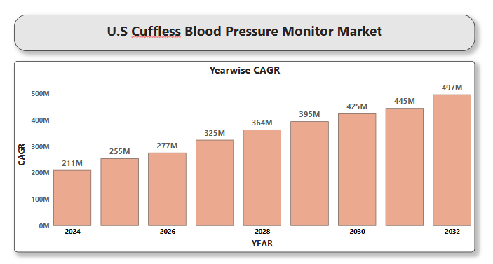

**U.S. Obesity Treatment Market**

**By** **Treatment Type** (Pharmacological Treatments, Surgical Treatments, Non-Surgical/Behavioral Therapies, Devices), **By** **Medication Type** (Prescription Medications, Over-the-Counter (OTC) Drugs), **By** **End Users** (Hospitals & Clinics, Weight Loss Centers, Home Care Settings), **By** **Distribution Channel** (Hospital Pharmacies, Retail Pharmacies, Online Pharmacies) **And by Region/Country**. Global and Regional Industry Overview, Market Intelligence, Comprehensive Analysis, Historical Data, and Forecasts 2024 – 2032

According to Intelli, the U.S. Obesity Treatment Market size was valued at USD 9,745.85 Million in 2024 and is projected to reach USD 54,558.48 Million by 2032, growing at a compound annual growth rate (CAGR) of 24.83% during the forecast period of 2024 to 2032.

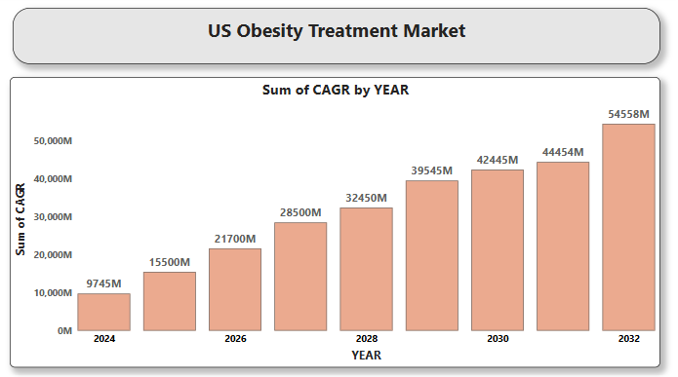

**U.S Schizophrenia Drugs Market**

**By Drug Class** (First-Generation (Typical) Antipsychotics, Second-Generation (Atypical) Antipsychotics, Dual-Receptor Antipsychotics, Glutamate Modulators, Mood Stabilizers, Antidepressants), **By Route of Administration** (Oral, Injectable, Intranasal), **By End-User** (Hospitals, Psychiatric Clinics, Outpatient Care, Homecare Services) **And by Region/Country**. Global and Regional Industry Overview, Market Intelligence, Comprehensive Analysis, Historical Data, and Forecasts 2024 – 2032

According to Intelli, the U.S Schizophrenia Drugs Market size was valued at USD 8,230.12 Million in 2024 and is projected to reach USD 12,233.61 Million by 2032, growing at a compound annual growth rate (CAGR) of 5.50 % during the forecast period of 2024 to 2032.

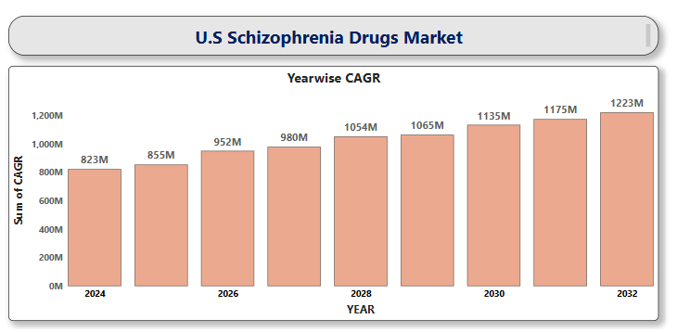

**U.S. Actigraphy Device Market**

**By Product Type** (Wrist Actigraphy Devices, Wearable Actigraphy Monitors), **By Technology** (Wireless Actigraphy Devices, USB/Manual Download Devices), **By End-User** (Healthcare Providers, Patients/Consumers, Academic & Research Institutions) **And by Region/Country**. Global and Regional Industry Overview, Market Intelligence, Comprehensive Analysis, Historical Data, and Forecasts 2024 – 2032

According to Intelli, the U.S. Actigraphy Device Market size was valued at USD 810.23 Million in 2024 and is projected to reach USD 4,414.52 Million by 2032, growing at a compound annual growth rate (CAGR) of 24.13% during the forecast period of 2024 to 2032.

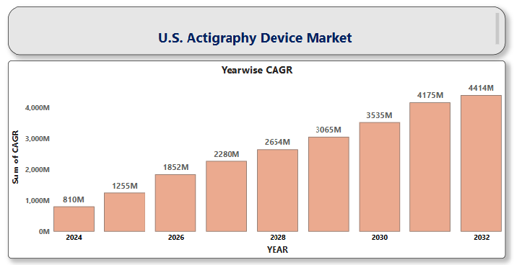

**U.S. AI in Medical Imaging Market**

**By Technology** (Deep Learning, Natural Language Processing, Other), **By Application** (Neurology, Cardiology, Breast Screening, Respiratory, Orthopaedics, Alzheimer’s Disease, Brain Tumors, Others), **By Imaging Modality** (Computed Tomography (CT) Scans, Magnetic Resonance Imaging (MRI), X-rays, Ultrasound, Nuclear Imaging), **By End-Users** (Hospitals, Diagnostic Imaging Centers, Others) **And by Region/Country.** Global and Regional Industry Overview, Market Intelligence, Comprehensive Analysis, Historical Data, and Forecasts 2024 – 2032

According to Intelli, the U.S. AI In Medical Imaging Market Size was valued at USD 260.8 Million in 2024 and is projected to reach USD 2,143.37million by 2032, growing at a compound annual growth rate (CAGR) of 30.65% during the forecast period of 2024 to 2032.

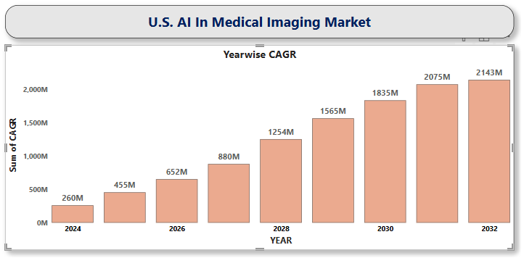

**U.S. Ankylosing Spondylitis Market**

**By Drug Class** (TNF Inhibitors, IL-17 Inhibitors, JAK Inhibitors, NSAIDs, Corticosteroids), **By Distribution Channel** (Hospital Pharmacies, Retail Pharmacies, Online Pharmacies), **By End-User** (Hospitals & Clinics, Home Care) **By End-Users** (Hospitals, Diagnostic Imaging Centers, Others) **And by Region/Country.** Global and Regional Industry Overview, Market Intelligence, Comprehensive Analysis, Historical Data, and Forecasts 2024 – 2032

According to Intelli, the U.S. Ankylosing Spondylitis Market size was valued at USD 5,814.55 Million in 2024 and is projected to reach USD 9,323.36 Million by 2032, growing at a compound annual growth rate (CAGR) of 6.50% during the forecast period of 2024 to 2032.

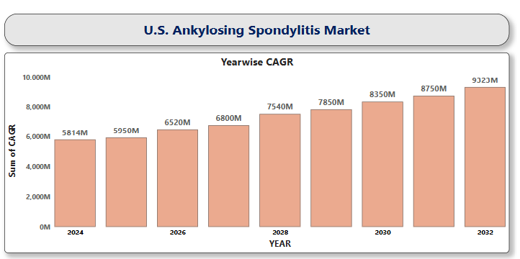

**U.S. Antibody Drug Conjugates Contract Manufacturing Market**

**By Condition** (Myeloma, Lymphoma, Breast Cancer, Others), **By Linker Type** (Cleavable Linkers, Non-cleavable Linkers), **By End-Use Phase** (Clinical Phase, Commercial Phase) **And by Region/Country.** Global and Regional Industry Overview, Market Intelligence, Comprehensive Analysis, Historical Data, and Forecasts 2024 – 2032

According to Intelli, the U.S. Antibody Drug Conjugates Contract Manufacturing Market size was valued at USD 1,901.3 Million in 2024 and is projected to reach USD 3,975.81 Million by 2032, growing at a compound annual growth rate (CAGR) of 10.08% during the forecast period of 2024 to 2032.

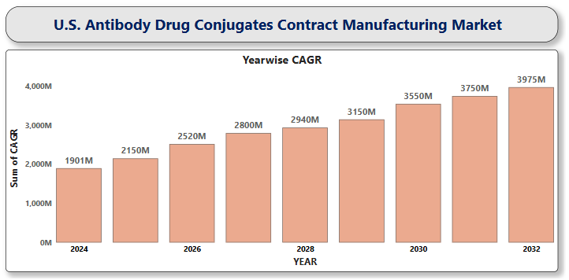

**U.S. Arrhythmia Monitoring Devices Market**

**By Product Type** (Electrocardiogram, Holter Monitors, Mobile Cardiac Telemetry, Wearable ECG Patches, Implantable Loop Recorders), **By End-User** (Hospitals, Ambulatory Surgical Centers, Home Care Settings, Diagnostic Centers), **By Distribution Channel** (Direct Sales, Online Sales, Retail Sales) **And by Region/Country.** Global and Regional Industry Overview, Market Intelligence, Comprehensive Analysis, Historical Data, and Forecasts 2024 – 2032

According to Intelli, the U.S. Arrhythmia Monitoring Devices Market size was valued at USD 2,470.4 Million in 2024 and is projected to reach USD 3,526.53 Million by 2032, growing at a compound annual growth rate (CAGR) of 4.97% during the forecast period of 2024 to 2032.

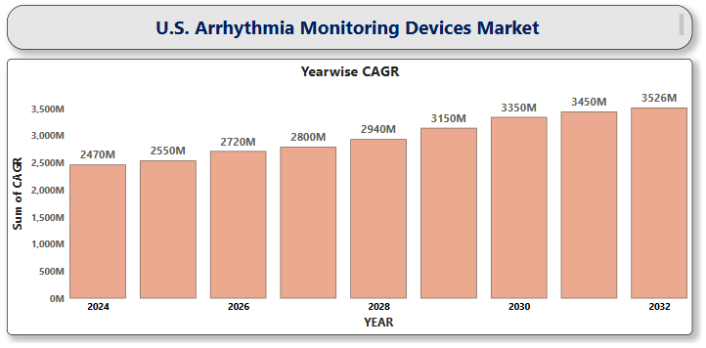

**U.S. Artificial Intelligence in Cancer Diagnostics Market**

**By Component** (Software Solution, Hardware, Services), **By Cancer Types** (Brain Tumor, Breast Cancer, Lung Cancer, Colorectal Cancer, Prostate Cancer, Others), **By End-Users** (Hospital, Surgical Centers & Medical Institute, Others) **And by Region/Country.** Global and Regional Industry Overview, Market Intelligence, Comprehensive Analysis, Historical Data, and Forecasts 2024 – 2032

According to Intelli, U.S. Artificial Intelligence in Cancer Diagnostics Market Size was valued at USD 121.1 Million in 2024 and is projected to reach USD 1,079.85 Million by 2032, growing at a compound annual growth rate (CAGR) of 22.15% during the forecast period of 2024 to 2032.

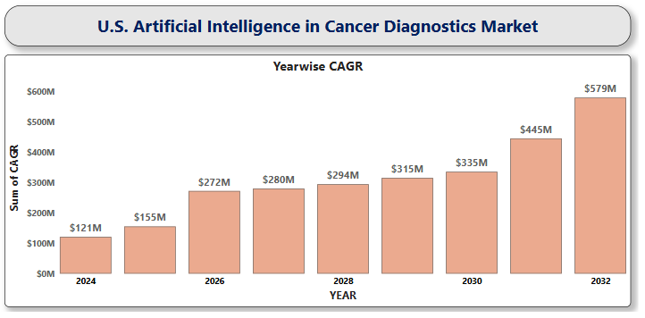

**U.S. Artificial Intelligence in Cardiology Market**

**By Component** (Software, Hardware, Services), **By Application** (Cardiac Arrhythmias, Coronary Artery Disease, Stroke), **By End User** (Hospitals, Diagnostic Centers, Research and Academic Institutes, Specialty Clinics) **And by Region/Country.** Global and Regional Industry Overview, Market Intelligence, Comprehensive Analysis, Historical Data, and Forecasts 2024 – 2032

According to Intelli, the U.S. Artificial Intelligence in Cardiology Market size was valued at USD 1,004.41 Million in 2024 and is projected to reach USD 5,442.53 Million by 2032, growing at a compound annual growth rate (CAGR) of 23.94% during the forecast period of 2024 to 2032.

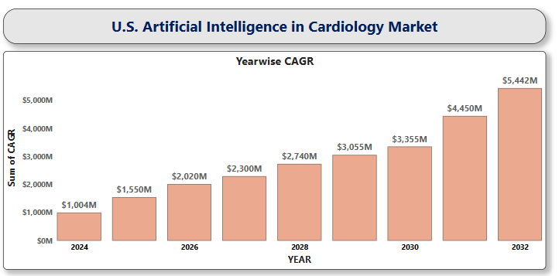

**U.S. Artificial Intelligence in Precision Medicine Market**

**By Technology** (Deep Learning, Natural Language Processing, Querying Methods, Context-Aware Processing), **By Therapeutic Application** (Cardiology, Oncology, Neurology, Respiratory), **By End User** (Healthcare Providers, Pharmaceutical Companies, Research Organizations) **And by Region/Country.** Global and Regional Industry Overview, Market Intelligence, Comprehensive Analysis, Historical Data, and Forecasts 2024 – 2032

According to Intelli, the U.S. Artificial Intelligence in Precision Medicine Market size was valued at USD 520.7Million in 2024 and is projected to reach USD 4,349.98 Million by 2032, growing at a compound annual growth rate (CAGR) of 31.51% during the forecast period of 2024 to 2032.

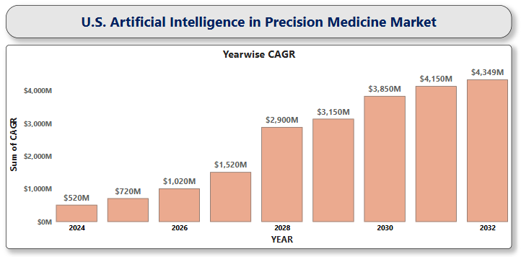

**U.S. Asthma Therapeutics Market**

**By Drug Type** (Quick-Relief Medications, Long-Term Control Medications, Biologics, Combination Therapies), **By Route of Administration** (Inhalation, Oral, Injectable), **By Distribution Channel** (Hospital Pharmacies, Online Pharmacies, Retail Pharmacies) **And by Region/Country.** Global and Regional Industry Overview, Market Intelligence, Comprehensive Analysis, Historical Data, and Forecasts 2024 – 2032

According to Intelli, the U.S. Asthma Therapeutics Market size was valued at USD 10,717.3 Million in 2024 and is projected to reach USD 14,780.16 Million by 2032, growing at a compound annual growth rate (CAGR) of 4.52% during the forecast period of 2024 to 2032.

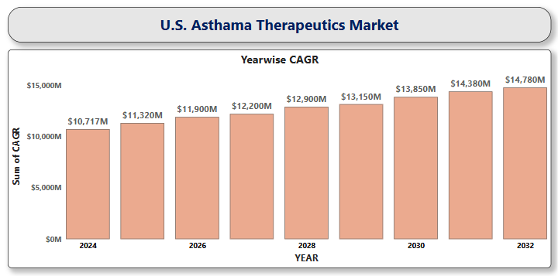

**U.S. Atopic Dermatitis Drugs Market**

**By Drug Class** (Biologics, Phosphodiesterase-4 (PDE4) Inhibitors, Corticosteroids, Janus Kinase (JAK) Inhibitors, Calcineurin Inhibitors), **By Route of Administration** (Topical, Oral, Injectable), **By Distribution Channels** (Hospital Pharmacies, Retail Pharmacies, Online Pharmacies) **And by Region/Country.** Global and Regional Industry Overview, Market Intelligence, Comprehensive Analysis, Historical Data, and Forecasts 2024 – 2032

According to Intelli, the U.S. Atopic Dermatitis Drugs Market size was valued at USD 6,002.85 Million in 2024 and is projected to reach USD 11,545.42 Million by 2032, growing at a compound annual growth rate (CAGR) of 8.94% during the forecast period of 2024 to 2032.

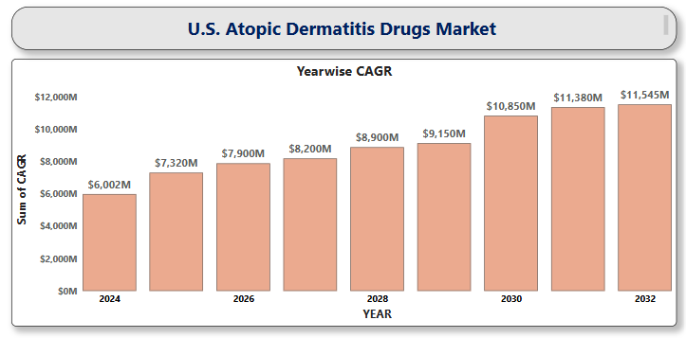

**U.S. Basal Cell Carcinoma Treatment Market**

**By Treatment Type** (Surgical Procedures, Radiotherapy, Topical Therapies, Oral Medications, Other Treatments), **By Stage of Disease** (Early-Stage Basal Cell Carcinoma, Advanced Basal Cell Carcinoma), **By Distribution Channel** (Hospitals and Clinics, Specialty Centers, Homecare Settings) **And by Region/Country.** Global and Regional Industry Overview, Market Intelligence, Comprehensive Analysis, Historical Data, and Forecasts 2024 – 2032

According to Intelli, the U.S. Basal Cell Carcinoma Treatment Market size was valued at USD 1,457.99 Million in 2024 and is projected to reach USD 3,199.85 million by 2032, growing at a compound annual growth rate (CAGR) of 10.85% during the forecast period of 2024 to 2032.

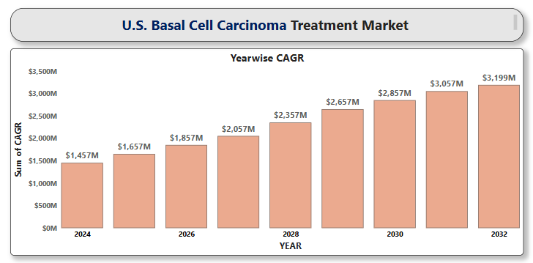

**U.S. Bioelectronic Skin Patches Market**

**By Type** (Electrochemical Sensors, ECG Sensors, Temperature Sensors, Electromyography Sensor, Others), **By Application** (Fitness and Wellness, Medical Monitoring, Others), **By End User** (Hospitals & Clinics, Home Care Settings, Others) **And by Region/Country.** Global and Regional Industry Overview, Market Intelligence, Comprehensive Analysis, Historical Data, and Forecasts 2024 – 2032

According to Intelli, the U.S. Bioelectronic Skin Patches Market Size was valued at USD 1,887.35 Million in 2024 and is projected to reach USD 4,641.22 Million by 2032, growing at a compound annual growth rate (CAGR) of 12.43% during the forecast period of 2024 to 2032.

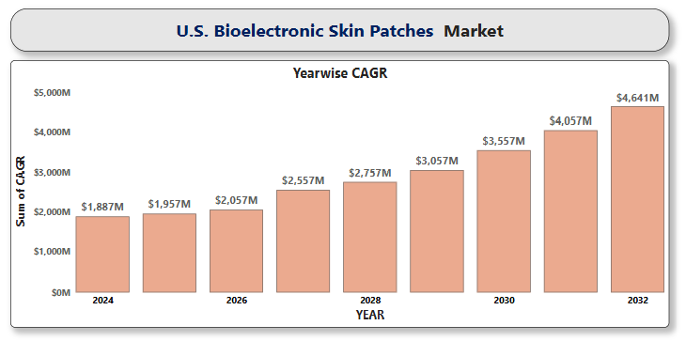

**U.S. Blood Cancer Diagnostics Market**

**By Product** (Assay Kits and Reagents, Instruments), **By Test Type** (Molecular Tests, Blood Tests, Imaging Tests and Biopsy), **By End-Use** (Hospitals and Clinics, Diagnostic Laboratories, Research Institutes) **And by Region/Country.** Global and Regional Industry Overview, Market Intelligence, Comprehensive Analysis, Historical Data, and Forecasts 2024 – 2032

According to Intelli, the U.S. Blood Cancer Diagnostics Market size was valued at USD 4,031.4 Million in 2024 and is projected to reach USD 6,701.9 Million by 2032, growing at a compound annual growth rate (CAGR) of 6.98% during the forecast period of 2024 to 2032.

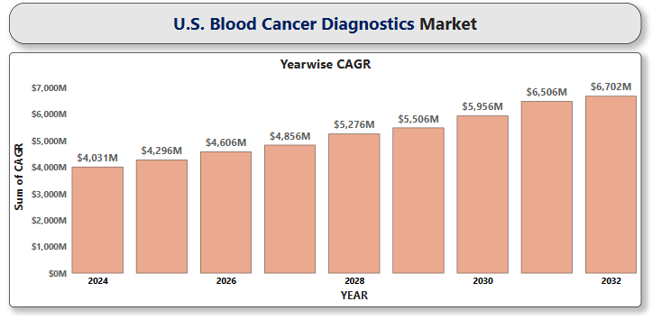

**U.S. Brain Mapping Instruments Market**

**By Product Type** (Electroencephalography (EEG) Devices, Magnetoencephalography (MEG) Devices, Functional Magnetic Resonance Imaging (fMRI), Near-Infrared Spectroscopy (NIRS), Computed Axial Tomography (CT or CAT) Scanners, Positron Emission Tomography (PET) Scanners), **By Application** (Neurology, Psychiatry, Cognitive Neuroscience, Clinical Diagnostics), **By End User** (Hospitals and Clinics, Research Institutes, Academic Institutions) **And by Region/Country.** Global and Regional Industry Overview, Market Intelligence, Comprehensive Analysis, Historical Data, and Forecasts 2024 – 2032

According to Intelli, the U.S. Brain Mapping Instruments Market Size was valued at USD 574.23 Million in 2024 and is projected to reach USD 867.30 Million by 2032, growing at a compound annual growth rate (CAGR) of 5.71% during the forecast period of 2024 to 2032.

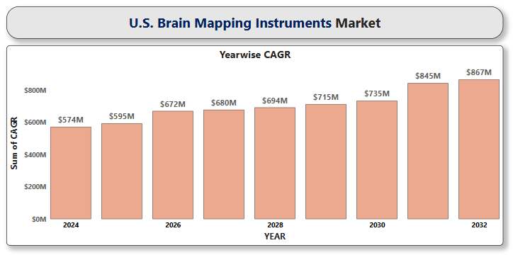

**U.S. Breast Cancer Core Needle Biopsy Market**

**By Type of Biopsy Technique** (Ultrasound-Guided Core Needle Biopsy, MRI-Guided Core Needle Biopsy, Stereotactic-Guided Core Needle Biopsy), **By Product** (Needle-Based Biopsy Guns, Vacuum-Assisted Biopsy Devices), **By End User** (Hospitals, Diagnostic & Imaging Centers, Ambulatory Surgical Centers, Academic & Research Institutes) **And by Region/Country.** Global and Regional Industry Overview, Market Intelligence, Comprehensive Analysis, Historical Data, and Forecasts 2024 – 2032

According to Intelli, the U.S. Breast Cancer Core Needle Biopsy Market size was valued at USD 380.56 Million in 2024 and is projected to reach USD 530.29 Million by 2032, growing at a compound annual growth rate (CAGR) of 4.76% during the forecast period of 2024 to 2032.

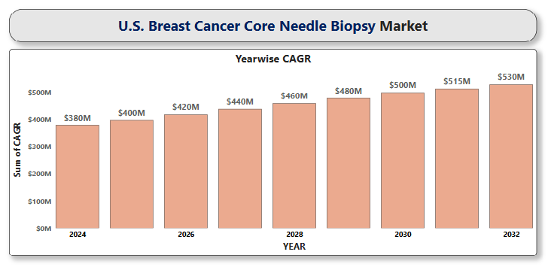

**U.S. Breast Cancer Drugs Market**

**By Drug Type** (Chemotherapy Drugs, Endocrine Therapy, Targeted Therapy, CDK 4/6 Inhibitors, Immunotherapy, PARP Inhibitors), **By Cancer Type** (Hormone Receptor-Positive Breast Cancer, HER2-Positive Breast Cancer, Triple-Negative Breast Cancer), **By End User** (Hospitals, Cancer Treatment Centers, Homecare Settings, Academic & Research Institutes) **And by Region/Country.** Global and Regional Industry Overview, Market Intelligence, Comprehensive Analysis, Historical Data, and Forecasts 2024 – 2032

According to Intelli, the U.S. Breast Cancer Drugs Market size was valued at USD 2,986.42 Million in 2024 and is projected to reach USD 4,565.75 Million by 2032, growing at a compound annual growth rate (CAGR) of 5.87% during the forecast period of 2024 to 2032.

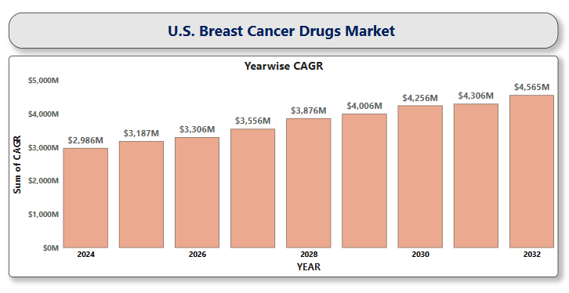

**U.S. Cancer Immunotherapy Market**

**By Cancer Type** (Melanoma, Lung Cancer, Breast Cancer, Colorectal Cancer (MSI-H/dMMR), Bladder Cancer, Renal Cell Carcinoma, Others), **By Therapy Type** (Monoclonal Antibodies, Immune Checkpoint Inhibitors, Adoptive Cell Therapy, Immunomodulators, Cancer Vaccines), **By End-User** (Hospitals, Specialty Clinics & Oncology Centers, Cancer Research Institute), **By Distribution Channel** (Hospital Pharmacies, Retail Pharmacies, Online Pharmacies) **And by Region/Country.** Global and Regional Industry Overview, Market Intelligence, Comprehensive Analysis, Historical Data, and Forecasts 2024 – 2032

According to Intelli, the U.S. Cancer Immunotherapy Market size was valued at USD 53,302 Million in 2024 and is projected to reach USD 91,918.95 Million by 2032, growing at a compound annual growth rate (CAGR) of 7.75% during the forecast period of 2024 to 2032.

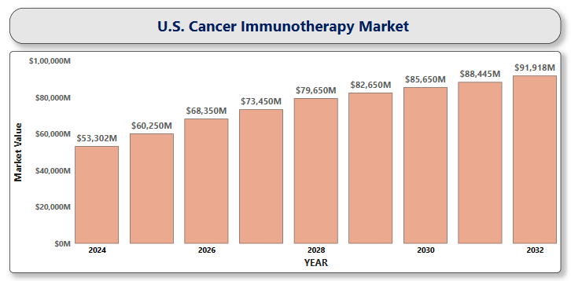

**U.S. Chemoinformatics Market**

**By Product Type** (Software, Services), **By Application** (Drug Discovery, Chemical Analysis, Drug Validation, Virtual Screening), **By End-User** (Pharmaceutical Companies, Biotechnology Firms, Academic and Research Institutions, Contract Research Organizations (CROs)), **And by Region/Country.** Global and Regional Industry Overview, Market Intelligence, Comprehensive Analysis, Historical Data, and Forecasts 2024 – 2032

According to Intelli, the U.S. Chemoinformatics Market size was valued at USD 1,232.7 Million in 2024 and is projected to reach USD 4,825.32 million by 2032, growing at a compound annual growth rate (CAGR) of 11.45% during the forecast period of 2024 to 2032.

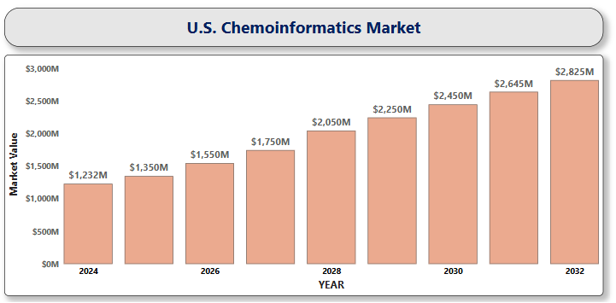

**U.S. Continuous Glucose Monitoring Devices Market**

**By Component** (Sensors, Transmitters & Receivers, Integrated Insulin Pumps), **By Technology** (Real-time CGM, Intermittently Scanned CGM), **By Application** (Type 1 Diabetes, Type 2 Diabetes), **By Demographics** (Adult, Paediatrics), **By Connectivity** (Bluetooth, 4G), **By End User** (Hospitals & Clinics, Homecare Settings, Diagnostic Centers),

**And by Region/Country.** Global and Regional Industry Overview, Market Intelligence, Comprehensive Analysis, Historical Data, and Forecasts 2024 – 2032

According to Intelli, the U.S. Continuous Glucose Monitoring Devices Market size was valued at USD 2,660 Million in 2024 and is projected to reach USD 5,263.16 million by 2032, growing at a compound annual growth rate (CAGR) of 9.43% during the forecast period of 2024 to 2032.

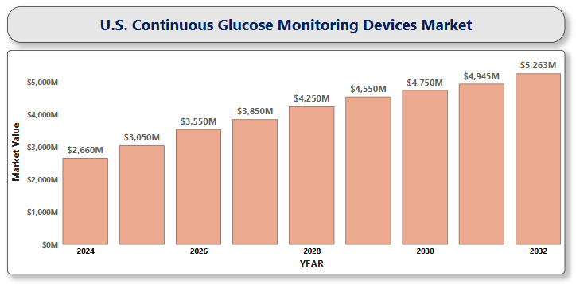

**U.S. Diabetic Neuropathy Management Devices Market**

**By Device Type** (Neuromodulation Devices, Wearable Devices, Magnetic Nerve Stimulation Devices, Monitoring and Diagnostic Devices), **By Indication** (Peripheral Neuropathy, Autonomic Neuropathy, Focal Neuropathy, Proximal Neuropathy), **By End User** (Hospitals & Clinics, Homecare Settings, Ambulatory Surgical Centers), **By Distribution Channel** (Online Platforms, Pharmacies & Retail Stores), **And by Region/Country.** Global and Regional Industry Overview, Market Intelligence, Comprehensive Analysis, Historical Data, and Forecasts 2024 – 2032

According to Intelli, the U.S. Diabetic Neuropathy Management Devices Market size was valued at USD 2,670.12 Million in 2024 and is projected to reach USD 13,278.50 Million by 2032, growing at a compound annual growth rate (CAGR) of 6.90% during the forecast period of 2024 to 2032.

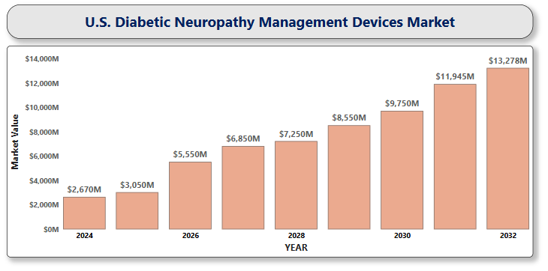

**U.S. Digital Health for Cardiovascular Market**

**By Component** (Software, Hardware, Services), **By End-User** (Patients, Providers, Payers, Others), **And by Region/Country.** Global and Regional Industry Overview, Market Intelligence, Comprehensive Analysis, Historical Data, and Forecasts 2024 – 2032

According to Intelli, the U.S. Digital Health for Cardiovascular Market size was valued at USD 24,493.85 Million in 2024 and is projected to reach USD 52,963.40 Million by 2032, growing at a compound annual growth rate (CAGR) of 10.54% during the forecast period of 2024 to 2032.

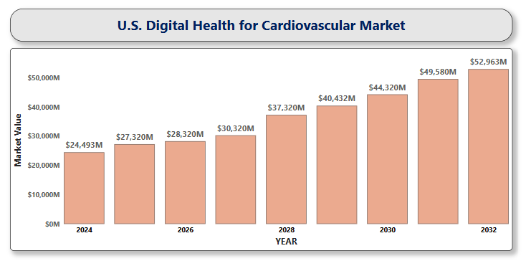

**U.S. Endoscopes Market**

**By Product Type** (Flexible Endoscopes, Rigid Endoscopes, Capsule Endoscopes, Disposable Endoscopes, Robot-Assisted Endoscopes), **By Application** (Gastroenterology, Pulmonology, Orthopedics, Urology, Gynecology, Neurology, ENT), **By End User** (Hospitals, Ambulatory Surgical Centers, Clinics, Diagnostic Centers), **And by Region/Country.** Global and Regional Industry Overview, Market Intelligence, Comprehensive Analysis, Historical Data, and Forecasts 2024 – 2032

According to Intelli, the U.S. Endoscopes Market size was valued at USD 4,682.40 Million in 2024 and is projected to reach USD 7,842.77 Million by 2032, growing at a compound annual growth rate (CAGR) of 7.08% during the forecast period of 2024 to 2032.

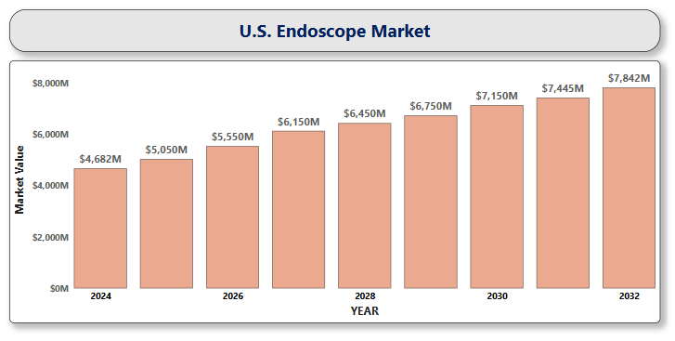

**U.S. Epigenetics Market**

**By Product Type** (Reagents & Kits, Enzymes, Instruments & Consumables, Bioinformatics Tools & Software), **By Technology** (DNA Methylation, Histone Modification, Chromatin Accessibility Assays, Non-coding RNA Analysis, Epigenome-Wide Association Studies (EWAS)), **By End User** (Pharmaceutical & Biotechnology Companies, Academic & Research Institutions, Clinical Laboratories, Contract Research Organizations (CROs), Hospitals & Diagnostic Centers), **And by Region/Country.** Global and Regional Industry Overview, Market Intelligence, Comprehensive Analysis, Historical Data, and Forecasts 2024 – 2032

According to Intelli, the U.S. Epigenetics Market size was valued at USD 5,527.5 Million in 2024 and is projected to reach USD 17,680.76Million by 2032, growing at a compound annual growth rate (CAGR) of 16.52% during the forecast period of 2024 to 2032.

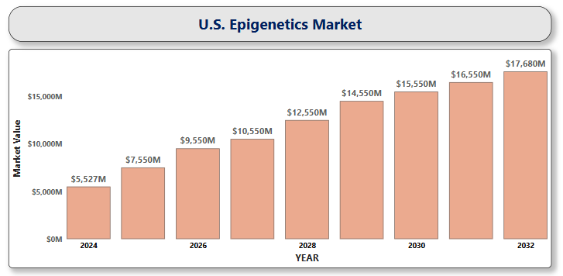

**U.S. Epilepsy Monitoring Devices Market**

**By Product Type** (EEG System, Wearable Seizure Detection Devices, Video EEG Monitoring Equipment, Implanted Neurostimulators, Mobile Health Applications), **By End-User** (Hospitals and Clinics, Home Care Settings, Ambulatory Surgical Centers), **And by Region/Country.** Global and Regional Industry Overview, Market Intelligence, Comprehensive Analysis, Historical Data, and Forecasts 2024 – 2032

According to Intelli, the U.S. Epilepsy Monitoring Devices Market size was valued at USD 220.54 Million in 2024 and is projected to reach USD 358.45 Million by 2032, growing at a compound annual growth rate (CAGR) of 6.68% during the forecast period of 2024 to 2032.

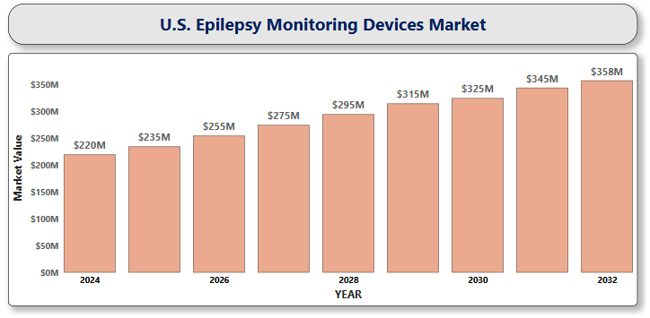

**U.S. Epithelioma Treatment Market**

**By Treatment Type** (Surgical Procedures, Radiation Therapy, Chemotherapy, Immunotherapy, Targeted Therapy, Cryotherapy and Laser Therapy, Topical Medications), **By Cancer Type** (Basal Cell Carcinoma, Squamous Cell Carcinoma, Other Epithelial Tumors), **By End User** (Hospitals, Specialty Clinics, Ambulatory Surgical Centers, Dermatology Centers), **And by Region/Country.** Global and Regional Industry Overview, Market Intelligence, Comprehensive Analysis, Historical Data, and Forecasts 2024 – 2032

According to Intelli, the U.S. Epithelioma Treatment Market size was valued at USD 1,891.3 Million in 2024 and is projected to reach USD 3,804.54 Million by 2032, growing at a compound annual growth rate (CAGR) of 9.55%, during the forecast period of 2024 to 2032.

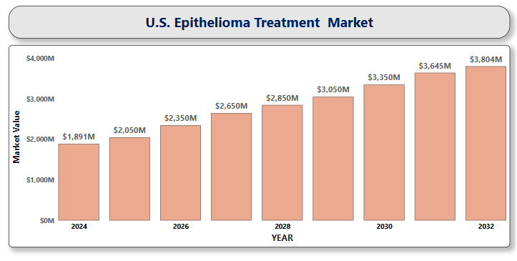

**U.S. Gastroesophageal Reflux Disease Therapeutics Market**

**By Drug Class** (PPIs, H2 Receptor Antagonists, Antacids, Prokinetic Agents, Alginate-Based Therapies), **By Treatment Type** (Pharmaceuticals, Surgical & Minimally Invasive Procedures), **By End-User** (Hospitals, Outpatient Clinics, Home Care Settings), **And by Region/Country.** Global and Regional Industry Overview, Market Intelligence, Comprehensive Analysis, Historical Data, and Forecasts 2024 – 2032

According to Intelli, the U.S. Gastroesophageal Reflux Disease Therapeutics Market size was valued at USD 1,980.7 Million in 2024 and is projected to reach USD 2,275.52 Million by 2032, growing at a compound annual growth rate (CAGR) of 2.17%, during the forecast period of 2024 to 2032.

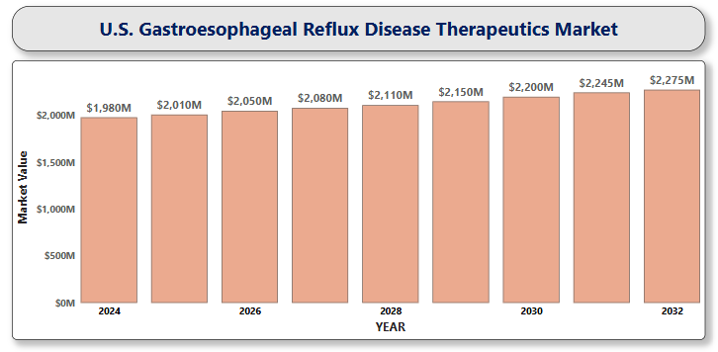

**U.S. GLP-1 Receptor Agonist Market**

**By Drug Type** (Semaglutide, Liraglutide, Dulaglutide, Exenatide, Tirzepatide), **By Application** (Type 2 Diabetes, Obesity/Weight Management, Cardiovascular Risk Reduction), **By Route of Administration** (Injectable, Oral), **By Distribution Channel** (Hospital Pharmacies, Retail Pharmacies, Online Pharmacies), **And by Region/Country.** Global and Regional Industry Overview, Market Intelligence, Comprehensive Analysis, Historical Data, and Forecasts 2024 – 2032

According to Intelli, the U.S. Glp-1 Receptor Agonist Market size was valued at USD 34,626.45 Million in 2024 and is projected to reach USD 1,16,725.54 Million by 2032, growing at a compound annual growth rate (CAGR) of 16.93%, during the forecast period of 2024 to 2032.

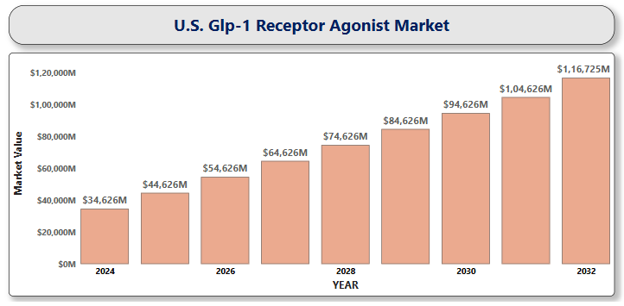

**U.S. Guillain-Barre Syndrome Market**

**By Therapeutic Type** (IVIG, Plasma Exchange, Others), **By Diagnostic Method** (Lumbar Puncture, Electromyography, Nerve Conduction Studies), **By Distribution Channel** (Hospital Pharmacies, Retail Pharmacies, Online Pharmacies), **And by Region/Country.** Global and Regional Industry Overview, Market Intelligence, Comprehensive Analysis, Historical Data, and Forecasts 2024 – 2032

According to Intelli, the U.S. Guillain-barre Syndrome Market size was valued at USD 268.52 Million in 2024 and is projected to reach USD 386.55 Million by 2032, growing at a compound annual growth rate (CAGR) of 5.08%, during the forecast period of 2024 to 2032.

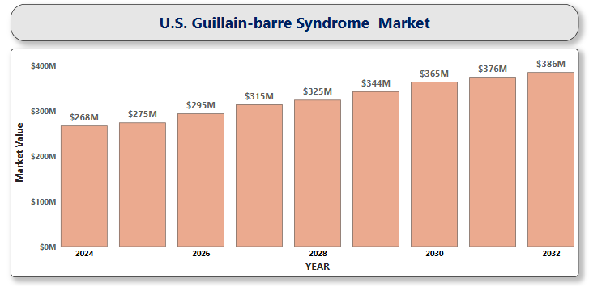

**U.S. Hemophilia Market**

**By Type** (Hemophilia A, Hemophilia B, Hemophilia C, Acquired Hemophilia), **By Treatment Type** (Factor Replacement Therapy, Non-factor Therapy, Gene Therapy, Antifibrinolytic Agents, Desmopressin), **By End User** (Hospitals, Specialty Clinics, Homecare Settings), **By Distribution Channel** (Hospital Pharmacies, Retail Pharmacies, Online Pharmacies), **And by Region/Country.** Global and Regional Industry Overview, Market Intelligence, Comprehensive Analysis, Historical Data, and Forecasts 2024 – 2032

According to Intelli, the U.S. Hemophilia Market size was valued at USD 6,413.09 Million in 2024 and is projected to reach USD 10,259.85 Million by 2032, growing at a compound annual growth rate (CAGR) of 6.47%, during the forecast period of 2024 to 2032.

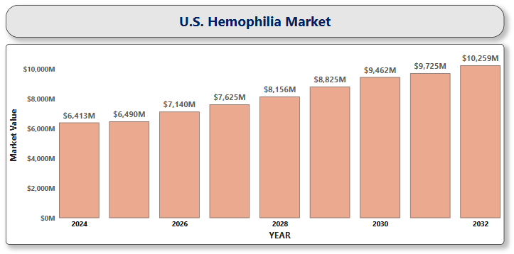

**U.S. Hereditary Angioedema Therapeutics Market**

**By Treatment Type** (C1 Esterase Inhibitors, Bradykinin B2 Receptor Antagonists, Kallikrein Inhibitors, Others / Emerging Therapies), **By Route of Administration** (Intravenous (IV), Subcutaneous (SC), Oral), **By Distribution Channel** (Hospital Pharmacies, Retail Pharmacies, Specialty Pharmacies), **And by Region/Country.** Global and Regional Industry Overview, Market Intelligence, Comprehensive Analysis, Historical Data, and Forecasts 2024 – 2032

According to Intelli, the U.S. Hereditary Angioedema Therapeutics Market size was valued at USD 1,032.42 Million in 2024 and is projected to reach USD 2,158.89 Million by 2032, growing at a compound annual growth rate (CAGR) of 10.08%, during the forecast period of 2024 to 2032.

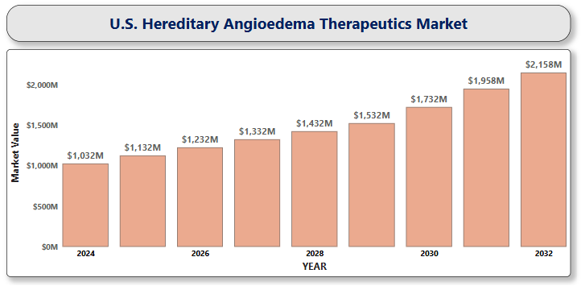

**U.S. Huntington’s Disease Treatment Market**

**By Drug Type** (Approved Drugs, Pipeline Drugs), **By Treatment Type** (Symptomatic Treatment, Disease-Modifying Treatment), **By Age** (Below 60 years, Above 60 years), **By End User** (Hospitals, Specialty Clinics, Homecare Settings, Research & Academic Institutes), **And by Region/Country.** Global and Regional Industry Overview, Market Intelligence, Comprehensive Analysis, Historical Data, and Forecasts 2024 – 2032

According to Intelli, the U.S. Huntington’s Disease Treatment Market size was valued at USD 285.99 Million in 2024 and is projected to reach USD 1,577.05 Million by 2032, growing at a compound annual growth rate (CAGR) of 21.49%, during the forecast period of 2024 to 2032.

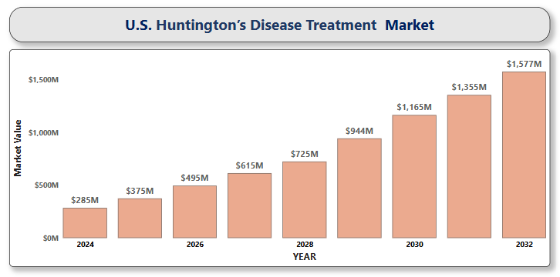

**U.S. Hydrocephalus Shunts Market**

**By Product Type** (Valves, Catheters), **By Patient Type** (Pediatric Patients, Adult Patients, Geriatric Patients), **By End-User** (Hospitals, Ambulatory Surgical Centers (ASCs), Specialty Clinics / Neurological Centers), **And by Region/Country.** Global and Regional Industry Overview, Market Intelligence, Comprehensive Analysis, Historical Data, and Forecasts 2024 – 2032

According to Intelli, the U.S. Hydrocephalus Shunts Market Size was valued at USD 130.79 Million in 2024 and is projected to reach USD 171.22 Million by 2032, growing at a compound annual growth rate (CAGR) of 3.95%, during the forecast period of 2024 to 2032.

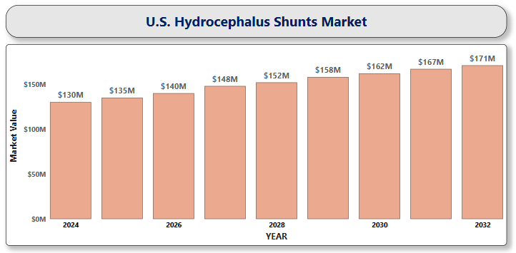

**U.S. Hyperspectral Imaging Systems Market**

**By Product Type** (Hyperspectral Cameras, Accessories), **By Technology** (Push Broom (Line-Scan), Snapshot (Area-Scan), Whisk Broom (Point-Scan), Tunable Filter Imaging, Other Emerging Technologies), **By Spectrum Range** (Visible/Near-Infrared (VNIR), Short-Wave Infrared (SWIR), Mid-Wave Infrared (MWIR), Long-Wave Infrared (LWIR)), **By Application** (Medical Diagnostics & Life Sciences, Food Quality & Safety Inspection, Forensic Science), **And by Region/Country.** Global and Regional Industry Overview, Market Intelligence, Comprehensive Analysis, Historical Data, and Forecasts 2024 – 2032

According to Intelli, the U.S. Hyperspectral Imaging Systems Market size was valued at USD 4,918.56 Million in 2024 and is projected to reach USD 11,457.13 Million by 2032, growing at a compound annual growth rate (CAGR) of 11.56%, during the forecast period of 2024 to 2032.

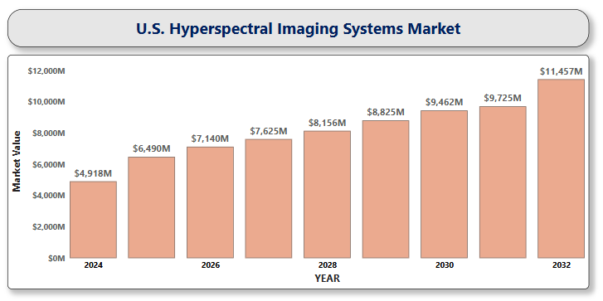

**U.S. Implantable Cardioverter Defibrillators Market**

**By Product Type** (Transvenous Implantable Cardioverter-Defibrillators, Subcutaneous Implantable Cardioverter Defibrillators), **By Patient Type** (Geriatric, Adult, Paediatric), **By NYHA Class Insights** (NYHA Class II, NYHA Class III), **By End-User** (Hospitals, Clinics, Public Access Market, Ambulatory Surgical Centers, Home, Others), **By Distribution Channel** (Online Stores, Distributors, Direct Sales), **And by Region/Country.** Global and Regional Industry Overview, Market Intelligence, Comprehensive Analysis, Historical Data, and Forecasts 2024 – 2032

According to Intelli, the U.S. Implantable Cardioverter Defibrillators Market size was valued at USD 5,220.5 Million in 2024 and is projected to reach USD 9,053.59 Million by 2032, growing at a compound annual growth rate (CAGR) of 7.65%, during the forecast period of 2024 to 2032.

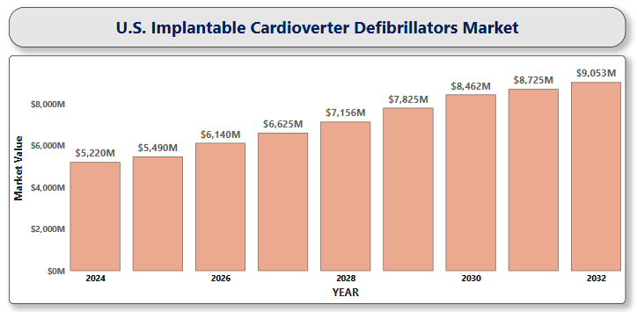

**U.S. Implantable Neurostimulators Market**

**By Product Type** (Spinal Cord Stimulators, Sacral Nerve Stimulators, Deep Brain Stimulators, Vagus Nerve Stimulators, Gastric Electric Stimulators), **By Product Application** (Pain Management, Epilepsy, Parkinson’s Disease, Gastroparesis, Others), **By End-User** (Hospitals, Specialty Clinics, Ambulatory Surgical Centers), **And by Region/Country.** Global and Regional Industry Overview, Market Intelligence, Comprehensive Analysis, Historical Data, and Forecasts 2024 – 2032

According to Intelli, the U.S. Implantable Neurostimulators Market size was valued at USD 4,202.14 Million in 2024 and is projected to reach USD 8,511.97 Million by 2032, growing at a compound annual growth rate (CAGR) of 9.75%, during the forecast period of 2024 to 2032.

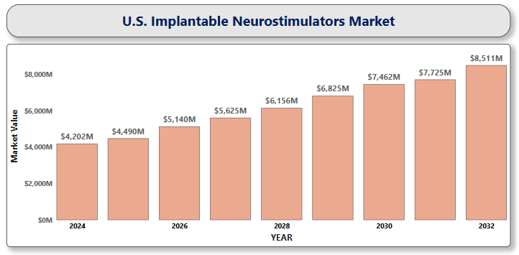

**U.S. Infertility Drugs Market**

**By Drug Type** (Fertility-Stimulating Drugs, Hormonal Therapy Drugs, Inhibitors, Sperm Production Enhancers), **By Application** (Female Infertility, Male Infertility), **By End-User** (Hospitals and Clinics, Fertility Centers, Homecare Settings), **By Distribution Channel** (Pharmacies, Hospitals and Clinics, E-commerce), **And by Region/Country.** Global and Regional Industry Overview, Market Intelligence, Comprehensive Analysis, Historical Data, and Forecasts 2024 – 2032

According to Intelli, the U.S. Infertility Drugs Market size was valued at USD 5,543.65 Million in 2024 and is projected to reach USD 8,035.56 Million by 2032, growing at a compound annual growth rate (CAGR) of 5.17%, during the forecast period of 2024 to 2032.

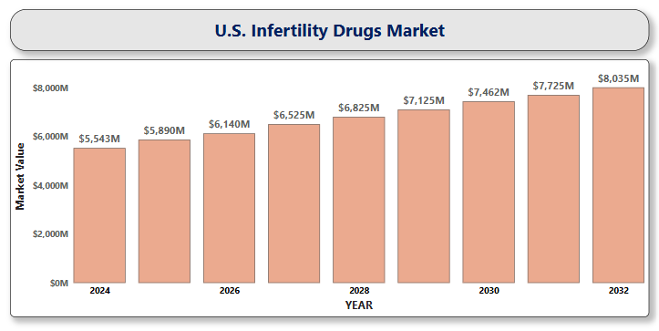

**U.S. Inhalation Anesthesia Market**

**By Product Type** (Volatile Anesthetics, Gaseous Anesthetics), **By Patient Group** (Adult Patients, Geriatric Patients, Pediatric Patients), **By End User** (Hospitals, Ambulatory Surgical Centers, Specialty Clinics), **And by Region/Country.** Global and Regional Industry Overview, Market Intelligence, Comprehensive Analysis, Historical Data, and Forecasts 2024 – 2032

According to Intelli, the U.S. Inhalation Anesthesia Market size was valued at USD 681.9 Million in 2024 and is projected to reach USD 1,129.36 Million by 2032, growing at a compound annual growth rate (CAGR) of 6.93%, during the forecast period of 2024 to 2032.

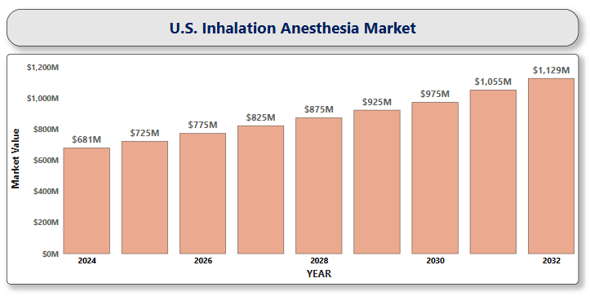

**U.S. Insulin Pens Market**

**By Product Type** (Reusable (Cartridge) Insulin Pens, Prefilled (Disposable) Insulin Pens, Smart Insulin Pens), **By End-User** (Hospitals & Clinics, Ambulatory Surgical Centers, Home Care Settings), **By Distribution Channel** (Hospital Pharmacies, Retail Pharmacies, Online Sales), **And by Region/Country.** Global and Regional Industry Overview, Market Intelligence, Comprehensive Analysis, Historical Data, and Forecasts 2024 – 2032

According to Intelli, the U.S. Insulin Pens Market size was valued at USD 2,353.71 Million in 2024 and is projected to reach USD 4,047.03 Million by 2032, growing at a compound annual growth rate (CAGR) of 7.43%, during the forecast period of 2024 to 2032.

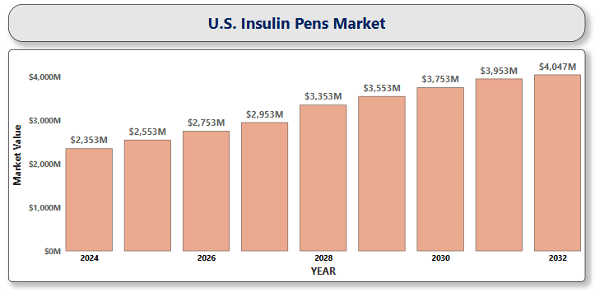

**U.S. Intravenous Infusion Pumps Market**

**By Product Type** (Volumetric Infusion Pumps, Patient-Controlled Analgesia (PCA) Pumps, Ambulatory Infusion Pumps, Syringe Infusion Pumps, Enteral and Implantable Infusion Pumps), **By Application** (Oncology, Pediatrics/Neonatology, Gastroenterology, Cardiology, Diabetes Management), **By End User** (Hospitals, Ambulatory Surgical Centers (ASCs), Home Healthcare Settings, Specialty Clinics), **And by Region/Country.** Global and Regional Industry Overview, Market Intelligence, Comprehensive Analysis, Historical Data, and Forecasts 2024 – 2032

According to Intelli, the U.S. Intravenous Infusion Pumps Market size was valued at USD 2,780.04 Million in 2024 and is projected to reach USD 5,151.17 Million by 2032, growing at a compound annual growth rate (CAGR) of 8.54%, during the forecast period of 2024 to 2032.

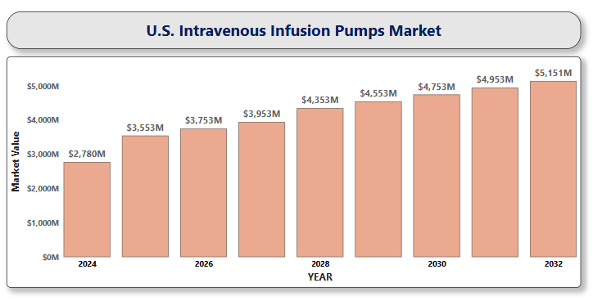

**U.S. Liver Cancer Drug Market**

**By Drug Type** (Targeted Therapy Drugs, Immunotherapy Drugs, Chemotherapy Drugs, Others), **By Cancer Type** (Hepatocellular Carcinoma, Intrahepatic Cholangiocarcinoma), **By Route of Administration** (Oral, Intravenous), **By End User** (Hospitals & Clinics, Cancer Research Institutes & Academic Medical Centers, Homecare Settings), **And by Region/Country.** Global and Regional Industry Overview, Market Intelligence, Comprehensive Analysis, Historical Data, and Forecasts 2024 – 2032

According to Intelli, the U.S. Liver Cancer Drug Market size was valued at USD 1,385.67 Million in 2024 and is projected to reach USD 4,756.34 Million by 2032, growing at a compound annual growth rate (CAGR) of 17.72%, during the forecast period of 2024 to 2032.

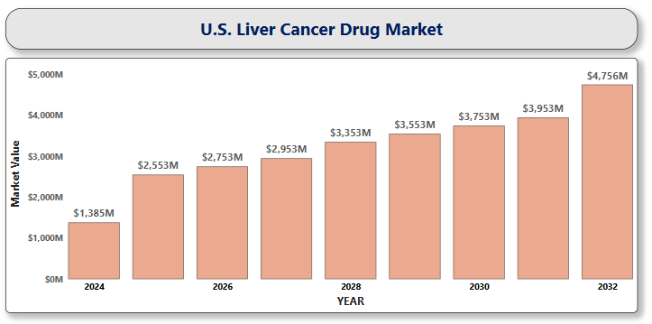

**U.S. Lung Cancer Diagnostics Market**

**By Diagnostic Test** (Imaging Tests, Biopsy Procedures, Liquid Biopsy, Molecular Diagnostics, Sputum Cytology), **By Cancer Type** (Non-Small Cell Lung Cancer, Small Cell Lung Cancer), **By End-User** (Hospitals & Clinics, Diagnostic Laboratories, Research Institutes & Academic Centers), **And by Region/Country.** Global and Regional Industry Overview, Market Intelligence, Comprehensive Analysis, Historical Data, and Forecasts 2024 – 2032

According to Intelli, the U.S. Lung Cancer Diagnostics Market size was valued at USD 4,738.05 Million in 2024 and is projected to reach USD 8,551.13 Million by 2032, growing at a compound annual growth rate (CAGR) of 8.08%, during the forecast period of 2024 to 2032.

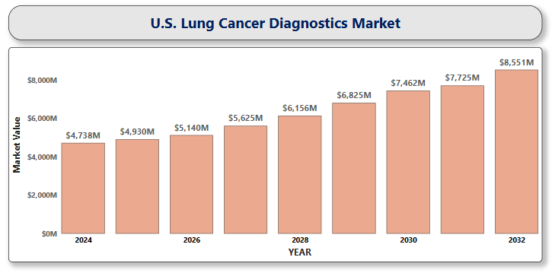

**U.S. Magnetoencephalography Market**

**By Application** (In Clinical Field, In Research Field), **By Technology** (Superconducting Magnetoencephalography, Optically Pumped Magnetometers), **By End-User** (Hospitals, Imaging Centers, Academic and Research Institutes), **And by Region/Country.** Global and Regional Industry Overview, Market Intelligence, Comprehensive Analysis, Historical Data, and Forecasts 2024 – 2032

According to Intelli, the U.S. Magnetoencephalography Market Size was valued at USD 85.1 Million in 2024 and is projected to reach USD 127.99 Million by 2032, growing at a compound annual growth rate (CAGR) of 5.76%, during the forecast period of 2024 to 2032.

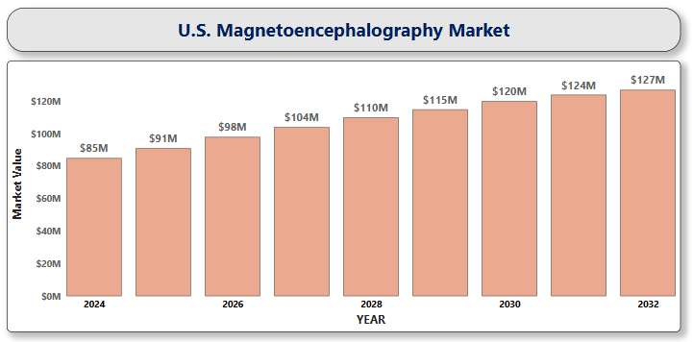

**U.S. Medical Smart Rings Market**

**By Product Type** (Health Monitoring Rings, Diagnostic Rings, Multifunctional Rings), **By Application** (Chronic Disease Management, Women’s Health, Remote Patient Monitoring, General Wellness and Fitness, Elderly Care), **By End-User** (Consumers, Healthcare Providers, Corporate Wellness Programs), **By Distribution Channel** (Online Channels, Offline Channels), **And by Region/Country.** Global and Regional Industry Overview, Market Intelligence, Comprehensive Analysis, Historical Data, and Forecasts 2024 – 2032

According to Intelli, the U.S. Medical Smart Rings Market size was valued at USD 61.4 Million in 2024 and is projected to reach USD 254.64 Million by 2032, growing at a compound annual growth rate (CAGR) of 20.16%, during the forecast period of 2024 to 2032.

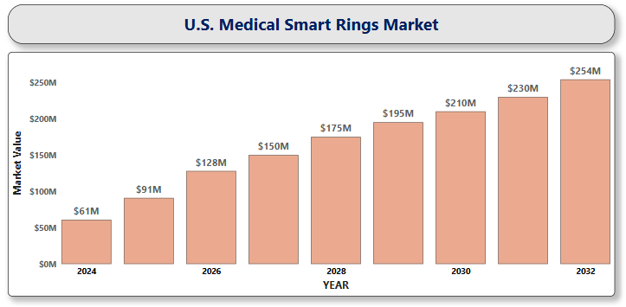

**U.S. Metastatic Lung Adenocarcinoma Treatment Market**

**By Therapy Type** (Chemotherapy, Targeted Therapy, Radiation Therapy, Immunotherapy, Others) **By Route of Administration** (Oral, Intravenous (IV)) **By Distribution Channel** (Hospital Pharmacies, Retail Pharmacies, Online Pharmacies, Specialty Clinics and Cancer Centers) **By End User** (Hospitals, Oncology Clinics, Academic & Research Institutes, Homecare Settings), **And by Region/Country.** Global and Regional Industry Overview, Market Intelligence, Comprehensive Analysis, Historical Data, and Forecasts 2024 – 2032

According to Intelli, the U.S. Metastatic Lung Adenocarcinoma Treatment Market size was valued at USD 1,802.31 Million in 2024 and is projected to reach USD 4,052.97 Million by 2032, growing at a compound annual growth rate (CAGR) of 11.08%, during the forecast period of 2024 to 2032.

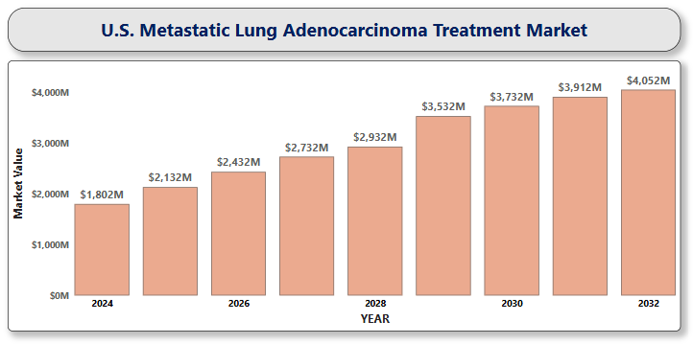

**U.S. Migraine Drugs Market**

**By Drug Type** (Acute/Abortive Treatment Drugs, Preventive/Prophylactic Drugs), **By Route of Administration** (Oral, Injectable, Nasal sprays, Transdermal patches), **By Distribution Channel** (Hospital pharmacies, Retail pharmacies, Online pharmacies), **And by Region/Country.** Global and Regional Industry Overview, Market Intelligence, Comprehensive Analysis, Historical Data, and Forecasts 2024 – 2032

According to Intelli, the U.S. Migraine Drugs Market size was valued at USD 2,892.31 Million in 2024 and is projected to reach USD 7,431.41 Million by 2032, growing at a compound annual growth rate (CAGR) of 12.94%, during the forecast period of 2024 to 2032.

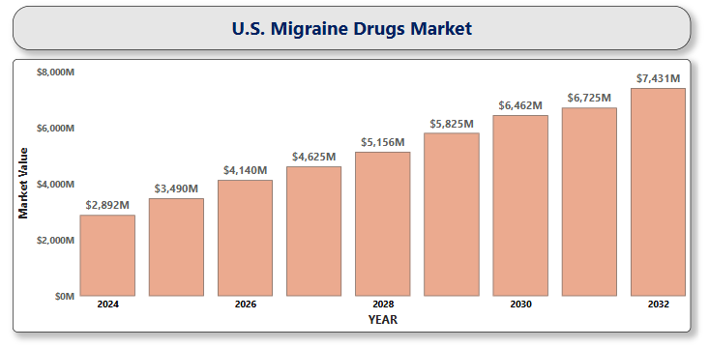

**U.S. Multiple Myeloma Therapeutics Market**

**By Treatment Type** (Chemotherapy, Targeted Therapy, Monoclonal Antibodies, Immunotherapy, Stem Cell Transplantation, Radiation Therapy), **By Route of Administration** (Oral, Injectable), **By Distribution Channel** (Hospital Pharmacies, Retail Pharmacies, Specialty Pharmacies), **By End-User** (Hospitals, Specialty Clinics, Homecare Settings), **And by Region/Country.** Global and Regional Industry Overview, Market Intelligence, Comprehensive Analysis, Historical Data, and Forecasts 2024 – 2032

According to Intelli, the U.S. Multiple Myeloma Therapeutics Market size was valued at USD 14,976.2 Million in 2024 and is projected to reach USD 23,307.20 Million by 2032, growing at a compound annual growth rate (CAGR) of 6.21%, during the forecast period of 2024 to 2032.

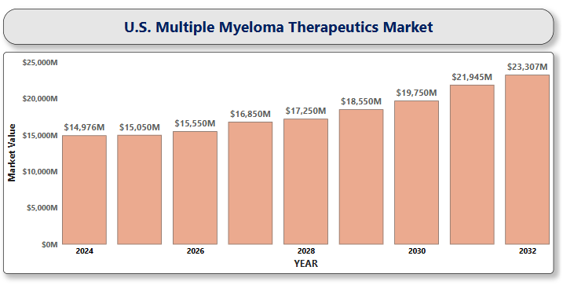

**U.S. Myasthenia Gravis Treatment Market**

**By Treatment Type** (Anticholinesterase Medications, Corticosteroids, Immunosuppressants, Monoclonal Antibodies (Biologics), IVIG Therapy, Plasmapheresis / Plasma Exchange (PLEX), Surgical Treatment), **By Disease Type** (Ocular Myasthenia Gravis, Generalized Myasthenia Gravis, Congenital Myasthenic Syndrome, Transient Neonatal Myasthenia Gravis), **By End User** (Hospitals, Specialty Neurology Clinics, Homecare Settings, Academic & Research Institutes), **And by Region/Country.** Global and Regional Industry Overview, Market Intelligence, Comprehensive Analysis, Historical Data, and Forecasts 2024 – 2032

According to Intelli, the U.S. Myasthenia Gravis Treatment Market size was valued at USD 898.3 Million in 2024 and is projected to reach USD 1,669.86 Million by 2032, growing at a compound annual growth rate (CAGR) of 8.65%, during the forecast period of 2024 to 2032.

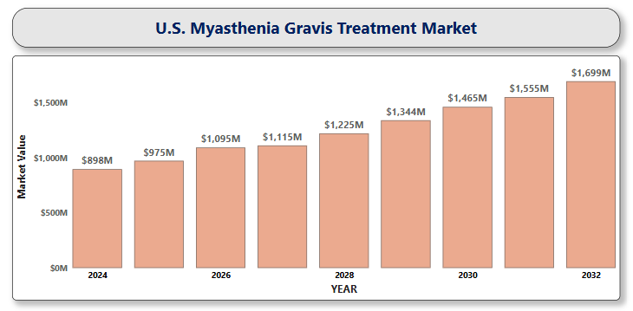

**U.S. Nanomedicine Market**

**By Application** (Drug Delivery, Diagnostic Imaging, Vaccines, Regenerative Medicine, Implants), **By Indication** (Oncology, Infectious Diseases, Cardiovascular Diseases, Neurological Disorders, Orthopedics), **By Molecular Type** (Nanoparticles, Nanotubes, Nanodevices, Nanoshells), **And by Region/Country.** Global and Regional Industry Overview, Market Intelligence, Comprehensive Analysis, Historical Data, and Forecasts 2024 – 2032

According to Intelli, the U.S. Nanomedicine Market size was valued at USD 96,664.3 Million in 2024 and is projected to reach USD 2,22,983.72 Million by 2032, growing at a compound annual growth rate (CAGR) of 11.89%, during the forecast period of 2024 to 2032.

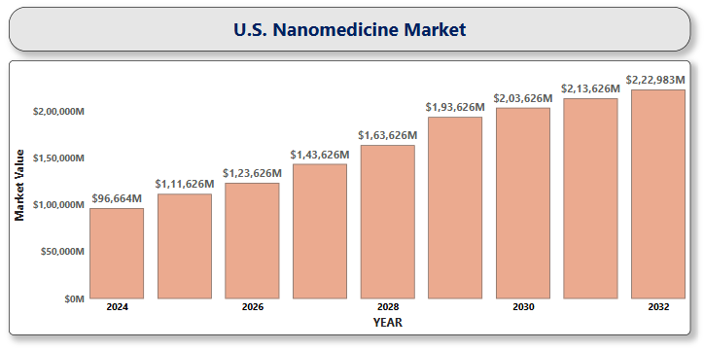

**U.S. Nephrology and Urology Devices Market**

**By Product Type** (Ureteral Catheters, Percutaneous Nephrostomy (PCN) Catheters, Urinary Stents, Stone Baskets, Renal Dilators, Urology Guidewires), **By Application** (Urolithiasis, Urological Cancer & Benign Prostatic Hyperplasia, Bladder Disorders, Kidney Diseases), **By End-User** (Hospitals and Clinics, Ambulatory Surgical Centers, Home Care Settings), **And by Region/Country.** Global and Regional Industry Overview, Market Intelligence, Comprehensive Analysis, Historical Data, and Forecasts 2024 – 2032

According to Intelli, the U.S. Nephrology and Urology Devices Market size was valued at USD 1,607.52 Million in 2024 and is projected to reach USD 2,670.38 Million by 2032, growing at a compound annual growth rate (CAGR) of 6.97%, during the forecast period of 2024 to 2032.

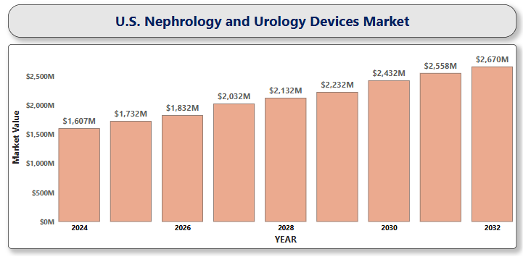

**U.S. Neurological Biomarkers Market**

**By Type** (Proteomics-based Biomarkers, Genomics-based Biomarkers, Metabolomics-based Biomarkers, Electrophysiology-based Biomarkers, Imaging-based Biomarkers), **By Application** (Alzheimer’s Disease, Parkinson’s Disease, Epilepsy, Multiple Sclerosis, Others), **By Technology** (Imaging Techniques, Biochemical Assays, Genetic Testing, EEG, Mass Spectrometry and Chromatography), **By End-User** (Hospitals and Clinics, Diagnostic Laboratories, Research and Academic Institutions), **And by Region/Country.** Global and Regional Industry Overview, Market Intelligence, Comprehensive Analysis, Historical Data, and Forecasts 2024 – 2032

According to Intelli, the U.S. Neurological Biomarkers Market size was valued at USD 2,947.3 Million in 2024 and is projected to reach USD 7,349.52 Million by 2032, growing at a compound annual growth rate (CAGR) of 12.52%, during the forecast period of 2024 to 2032.

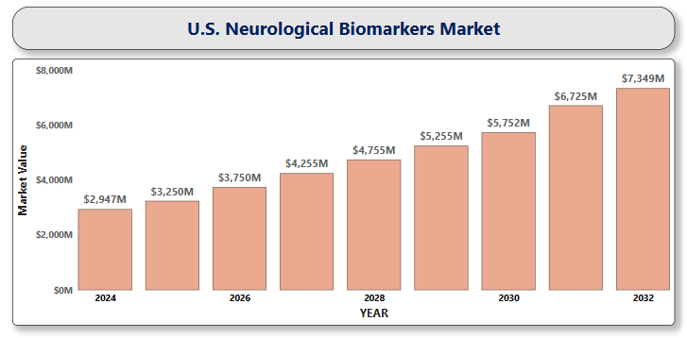

**U.S. Neurorehabilitation Devices Market**

**By Product Type** (Neurorobotic Systems, Brain-Computer Interfaces, Wearable Devices, Non-Invasive Stimulators), **By Application** (Stroke, Parkinson's Disease, Cerebral Palsy, Brain and Spinal Cord Injury, Multiple Sclerosis), **By End-User** (Hospitals and Clinics, Rehabilitation Centers, Home Care), **And by Region/Country.** Global and Regional Industry Overview, Market Intelligence, Comprehensive Analysis, Historical Data, and Forecasts 2024 – 2032

According to Intelli, the U.S. Neurorehabilitation Devices Market size was valued at USD 737.50 Million in 2024 and is projected to reach USD 1,900.97Million by 2032, growing at a compound annual growth rate (CAGR) of 13.09%, during the forecast period of 2024 to 2032.

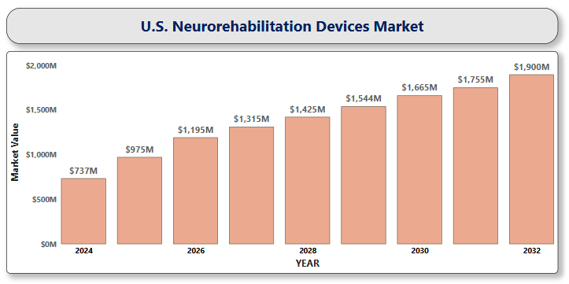

**U.S. Non-opioid Pain Patches Market**

**By Patch Type** (Lidocaine Patches, Diclofenac Patches, Capsaicin Patches, Methyl Salicylate and Ketoprofen Patches), **By Therapeutic Applications** (Chronic Pain Relief, Acute Pain Relief, Musculoskeletal Pain Relief, Postoperative Pain Management), **By Distribution Channels** (Retail Pharmacies, Online Pharmacies, Hospital Pharmacies), **And by Region/Country.** Global and Regional Industry Overview, Market Intelligence, Comprehensive Analysis, Historical Data, and Forecasts 2024 – 2032

According to Intelli, the U.S. Non-opioid Pain Patches Market size was valued at USD 317.8 Million in 2024 and is projected to reach USD 464.71 Million by 2032, growing at a compound annual growth rate (CAGR) of 5.39%, during the forecast period of 2024 to 2032.

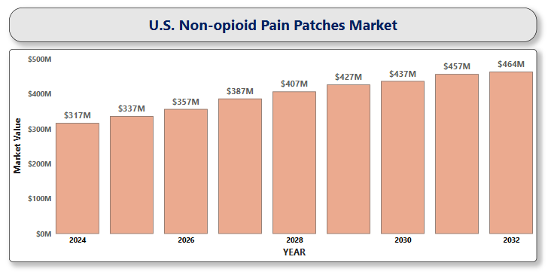

**U.S. non-small cell lung cancer (NSCLC) therapeutics Market**

**By Cancer Type** (Adenocarcinoma, Squamous Cell Carcinoma, Large Cell Carcinoma), **By Therapy Type** (Chemotherapy, Targeted Therapy, Immunotherapy, Combination Therapy, Radiation Therapy, Others), **By Route of Administration** (Oral, Intravenous (IV)), **By End Users** (Hospitals, Speciality Clinics, Others), **And by Region/Country.** Global and Regional Industry Overview, Market Intelligence, Comprehensive Analysis, Historical Data, and Forecasts 2024 – 2032

According to Intelli, the U.S. non-small cell lung cancer (NSCLC) therapeutics Market size was valued at USD 5,478.23 Million in 2024 and is projected to reach USD 14351.01 million by 2032, growing at a compound annual growth rate (CAGR) of 13.32%, during the forecast period of 2024 to 2032.

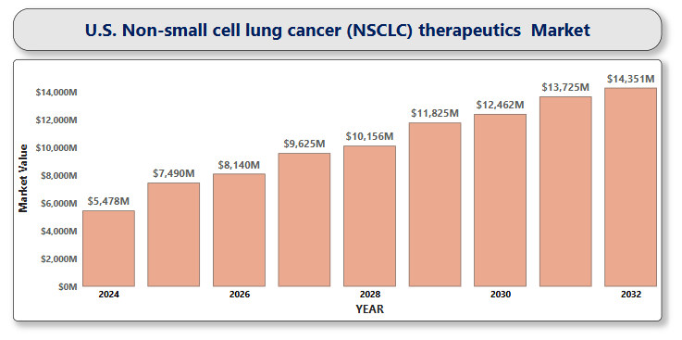

**U.S. Ocular Implants Market**

**By Product Type** (Intraocular Lenses, Corneal Implants, Glaucoma Implants, Orbital Implants, Ocular Prostheses), **By Application** (Cataract Surgery, Glaucoma Treatment, Retinal Disorders, Cosmetic Restoration, Age-related Macular Degeneration (AMD)), **By End-User** (Hospitals, Ophthalmic Clinics, Ambulatory Surgical Centers (ASCs), Academic & Research Institutes), **And by Region/Country.** Global and Regional Industry Overview, Market Intelligence, Comprehensive Analysis, Historical Data, and Forecasts 2024 – 2032

According to Intelli, the U.S. Ocular Implants Market size was valued at USD 3,461.60 Million in 2024 and is projected to reach USD 5,121.77Million by 2032, growing at a compound annual growth rate (CAGR) of 5.72%, during the forecast period of 2024 to 2032.

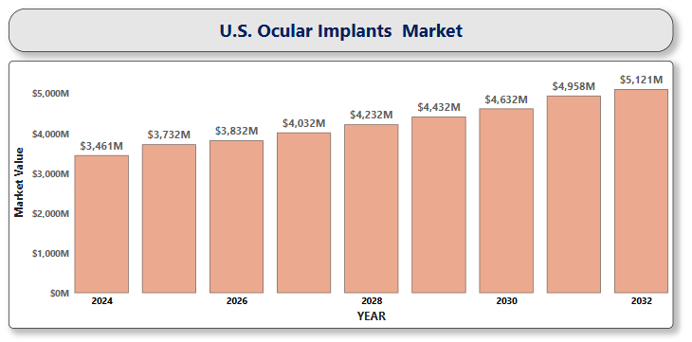

**U.S. ovarian cancer drugs market**

**By Drug Class** (Chemotherapy Drugs, PARP Inhibitors, Angiogenesis Inhibitors, Hormonal Therapy, Immunotherapy), **By Route of Administration** (Oral, Intravenous (IV)), **By Distribution Channel** (Hospital Pharmacies, Retail Pharmacies, Online Pharmacies), **By End User** (Hospitals, Cancer Treatment Centers, Research Institutes, Homecare Settings), **And by Region/Country.** Global and Regional Industry Overview, Market Intelligence, Comprehensive Analysis, Historical Data, and Forecasts 2024 – 2032

According to Intelli, the U.S. ovarian cancer drugs market size was valued at USD 1,611 Million in 2024 and is projected to reach USD 2,619.39 Million by 2032, growing at a compound annual growth rate (CAGR) of 6.79%, during the forecast period of 2024 to 2032.

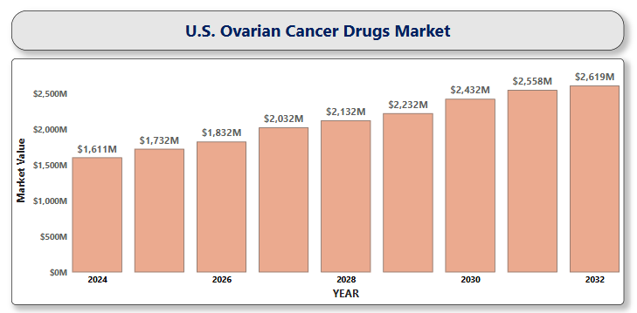

**U.S. Pancreatic Cancer Treatment Market**

**By Treatment Type** (Surgery, Radiation Therapy, Chemotherapy, Immunotherapy, Targeted Therapy), **By Cancer Type** (Exocrine Pancreatic Cancer, Endocrine Pancreatic Cancer), **By End-User** (Hospitals, Specialty Clinics, Cancer Research Centers), **And by Region/Country.** Global and Regional Industry Overview, Market Intelligence, Comprehensive Analysis, Historical Data, and Forecasts 2024 – 2032

According to Intelli, the U.S. Pancreatic Cancer Treatment Market size was valued at USD 1,130.43 Million in 2024 and is projected to reach USD 2,728.61 Million by 2032, growing at a compound annual growth rate (CAGR) of 12.17%, during the forecast period of 2024 to 2032.

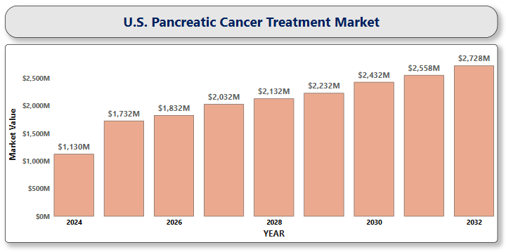

**U.S. Parkinson’s Disease Treatment Market**

**By Drug Class** (Carbidopa-Levodopa, MAO-B Inhibitors, Dopamine Agonists, COMT Inhibitors, Anticholinergics), **By Treatment Type** (Medication, Surgical Therapy, Carbidopa/Levodopa Enteral Suspension), **By Route of Administration** (Oral, Injectable, Transdermal), **By Distribution Channel** (Hospital Pharmacy, Specialty Pharmacy, Online Pharmacy), **And by Region/Country.** Global and Regional Industry Overview, Market Intelligence, Comprehensive Analysis, Historical Data, and Forecasts 2024 – 2032

According to Intelli, the U.S. Parkinson’s Disease Treatment Market size was valued at USD 1,947.9 Million in 2024 and is projected to reach USD 2,848.34 Million by 2032, growing at a compound annual growth rate (CAGR) of 5.39%, during the forecast period of 2024 to 2032.

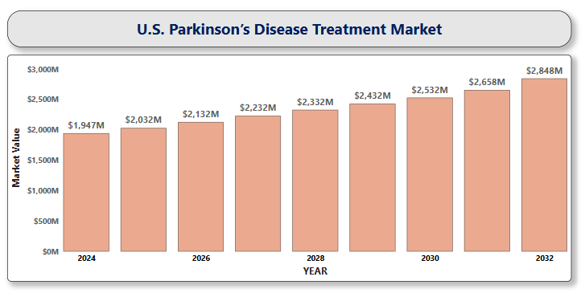

**U.S. Pediatric Medical Devices Market**

**By Product Type** (Cardiology Devices, Diagnostic Imaging Devices, Anesthesia & Respiratory Care Devices, Neonatal ICU Devices, In Vitro Diagnostic (IVD) Devices, Surgical Instruments), **By Technology** (Telemedicine & Remote Monitoring, 3D Imaging & Robotics, Miniaturized Technology), **By End-User** (Hospitals, Clinics, Ambulatory Surgical Centers, Home Care), **And by Region/Country.** Global and Regional Industry Overview, Market Intelligence, Comprehensive Analysis, Historical Data, and Forecasts 2024 – 2032

According to Intelli, the U.S. Pediatric Medical Devices Market Size was valued at USD 12,828.6 Million in 2024 and is projected to reach USD 24,160.37 Million by 2032, growing at a compound annual growth rate (CAGR) of 8.76%, during the forecast period of 2024 to 2032.

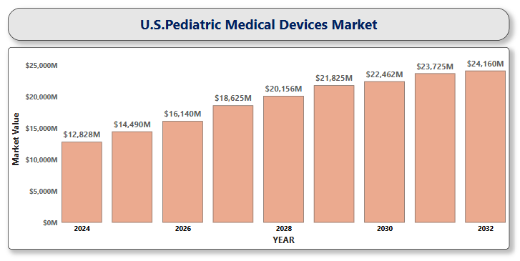

**U.S. Pet Scanners Market**

**By Modality** (PET-CT, PET-MRI), **By Application** (Oncology, Cardiology, Neurology, Others), **By End-User** (Hospitals, Diagnostic Imaging Centers, Ambulatory Surgical Centers (ASCs), Research Institutes), **And by Region/Country.** Global and Regional Industry Overview, Market Intelligence, Comprehensive Analysis, Historical Data, and Forecasts 2024 – 2032

According to Intelli, the U.S. Pet Scanners Market size was valued at USD 772.20 Million in 2024 and is projected to reach USD 1,151.75 Million by 2032, growing at a compound annual growth rate (CAGR) of 5.65%, during the forecast period of 2024 to 2032.

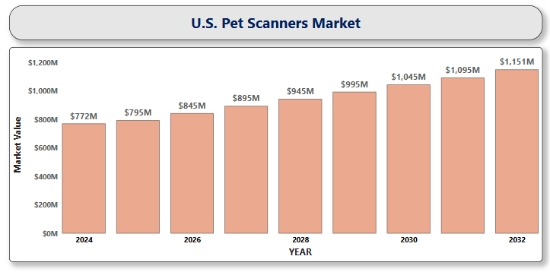

**U.S. Photomedicine Devices and Technologies Market**

**By Product Type** (Lasers, Photodynamic Therapy Devices, Fluorescence and Bioluminescence Imaging Systems, Wearable and Portable Light Therapy Devices, LEDs), **By Technology** (Photobiomodulation, Photothermal Therapy, Fluorescence-Guided Imaging, Laser Surgery and Ablation), **By Application** (Oncology, Dermatology, Ophthalmology, Neurology, Wound Healing and Regenerative Medicine, Cosmetic and Aesthetic Procedures), **By End User** (Hospitals and Clinics, Ambulatory Surgical Centers, Homecare Settings, Academic and Research Institutions), **And by Region/Country.** Global and Regional Industry Overview, Market Intelligence, Comprehensive Analysis, Historical Data, and Forecasts 2024 – 2032

According to Intelli, the U.S. Photomedicine Devices and Technologies Market size was valued at USD 1,419.9 Million in 2024 and is projected to reach USD 3,169.80 Million by 2032, growing at a compound annual growth rate (CAGR) of 10.98%, during the forecast period of 2024 to 2032.

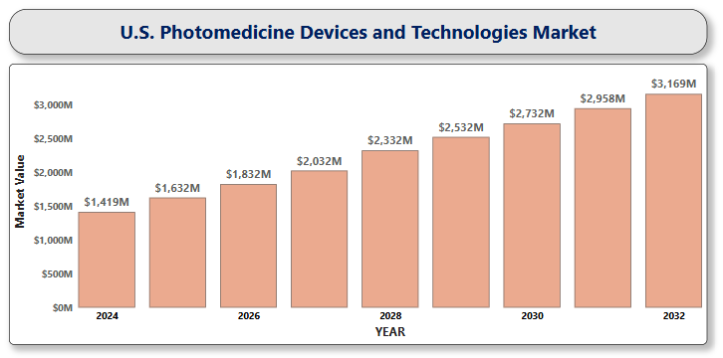

**U.S. Postmenopausal Osteoporosis Treatment Market**

**By Drug Class** (Bisphosphonates, Selective Estrogen Receptor Modulators, Hormone Replacement Therapy, Monoclonal Antibodies, Anabolic Agents), **By Route of Administration** (Oral, Transdermal, Injectable), **By Distribution Channel** (Hospital Pharmacies, Online Pharmacies, Retail Pharmacies), **By End User** (Hospitals and Clinics, Ambulatory Surgical Centers, Homecare Settings, Academic and Research Institutions), **And by Region/Country.** Global and Regional Industry Overview, Market Intelligence, Comprehensive Analysis, Historical Data, and Forecasts 2024 – 2032

According to Intelli, the U.S. Postmenopausal Osteoporosis Treatment Market size was valued at USD 3,442.62 Million in 2024 and is projected to reach USD 4,998.65 Million by 2032, growing at a compound annual growth rate (CAGR) of 5.29%, during the forecast period of 2024 to 2032.

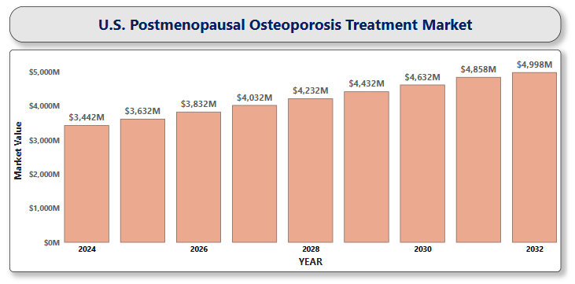

**U.S. Prostate Cancer Diagnostics Market**

**By Test Type** (Preliminary Screening Tests, Imaging Techniques, Biopsy Procedures, Molecular and Genomic Testing, Liquid Biopsies), **By Cancer Type** (Localized Prostate Cancer, Advanced/Metastatic Prostate Cancer), **By End User** (Hospitals, Diagnostic Laboratories, Ambulatory Surgical Centers, Cancer Research Centers), **And by Region/Country.** Global and Regional Industry Overview, Market Intelligence, Comprehensive Analysis, Historical Data, and Forecasts 2024 – 2032

According to Intelli, the U.S. Prostate Cancer Diagnostics Market size was valued at USD 2,215.97 Million in 2024 and is projected to reach USD 3,245.28 Million by 2032, growing at a compound annual growth rate (CAGR) of 5.41%, during the forecast period of 2024 to 2032.

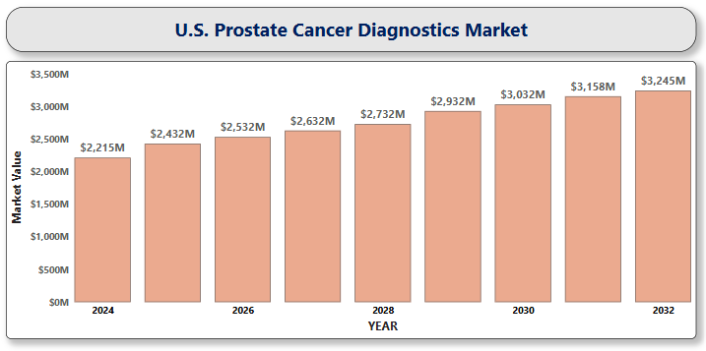

**U.S. Psychiatric Digital Biomarkers Market**

**By Type** (Wearables, Mobile-Based Applications, Sensors), **By Clinical Practice** (Diagnostic Psychiatric Digital Biomarkers, Monitoring Psychiatric Digital Biomarkers, Predictive and Prognostic Psychiatric Digital Biomarkers), **By End Use** (Healthcare Companies, Healthcare Providers, Payers), **And by Region/Country.** Global and Regional Industry Overview, Market Intelligence, Comprehensive Analysis, Historical Data, and Forecasts 2024 – 2032

According to Intelli, the U.S. Psychiatric Digital Biomarkers Market size was valued at USD 298.9 Million in 2024 and is projected to reach USD 1,567.78 Million by 2032, growing at a compound annual growth rate (CAGR) of 22.78%, during the forecast period of 2024 to 2032.

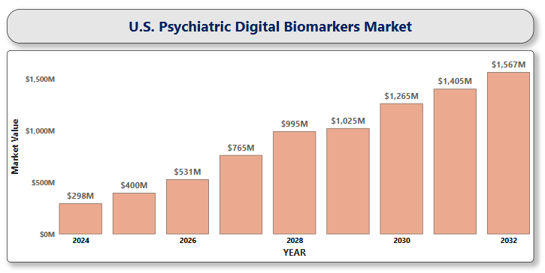

**U.S. Rheumatoid Arthritis Therapeutics Market**

**By Drug Class** (Conventional DMARDs, Biologic DMARDs, JAK Inhibitors, NSAIDs and Corticosteroids), **By Route of Administration** (Oral, Injectable, Infusion), **By Distribution Channel** (Hospital Pharmacies, Retail Pharmacies, Online Pharmacies), **And by Region/Country.** Global and Regional Industry Overview, Market Intelligence, Comprehensive Analysis, Historical Data, and Forecasts 2024 – 2032

According to Intelli, the U.S. Rheumatoid Arthritis Therapeutics Market size was valued at USD 16,428.05 Million in 2024 and is projected to reach USD 23,398.13 Million by 2032, growing at a compound annual growth rate (CAGR) of 4.94%, during the forecast period of 2024 to 2032.

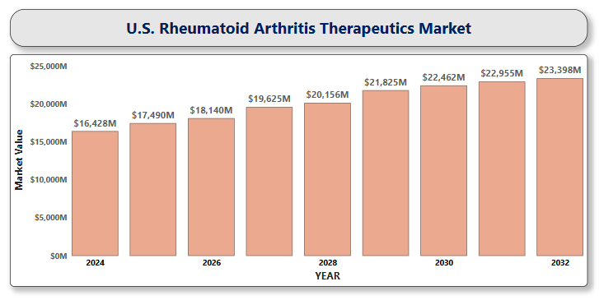

**U.S. Scleroderma Therapeutics Market**

**By Drug Type** (Immunosuppressants, Corticosteroids, Endothelin Receptor Antagonists, Phosphodiesterase-5 Inhibitors, Prostacyclin Analogs, Tyrosine Kinase Inhibitors, Biologics and Monoclonal Antibodies), **By Indication** (Localized Scleroderma, Systemic Sclerosis), **By Route of Administration** (Oral, Parenteral, Topical), **By End-User** (Hospitals, Specialty Clinics, Homecare Settings), **And by Region/Country.** Global and Regional Industry Overview, Market Intelligence, Comprehensive Analysis, Historical Data, and Forecasts 2024 – 2032

According to Intelli, the U.S. Scleroderma Therapeutics Market size was valued at USD 1,084.85 Million in 2024 and is projected to reach USD 1,456.34 Million by 2032, growing at a compound annual growth rate (CAGR) of 4.17%, during the forecast period of 2024 to 2032.

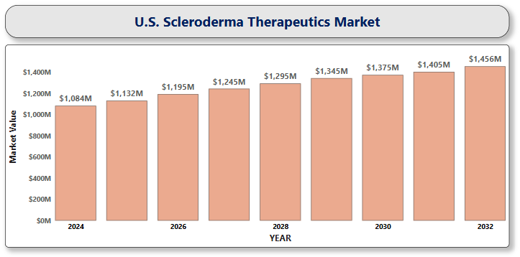

**U.S. Sepsis Therapeutics Market**

**By Drug Class** (Antibiotics, Corticosteroids, Vasopressors, Immunoglobulins), **By Route of Administration** (Intravenous, Oral), **By Patient Type** (Adult, Pediatric, Geriatric), **By Distribution Channel** (Hospital Pharmacies, Retail Pharmacies, Online Pharmacies), **And by Region/Country.** Global and Regional Industry Overview, Market Intelligence, Comprehensive Analysis, Historical Data, and Forecasts 2024 – 2032

According to Intelli, the U.S. Sepsis Therapeutics Market size was valued at USD 1,178.15 Million in 2024 and is projected to reach USD 1,846.79 Million by 2032, growing at a compound annual growth rate (CAGR) of 6.20%, during the forecast period of 2024 to 2032.

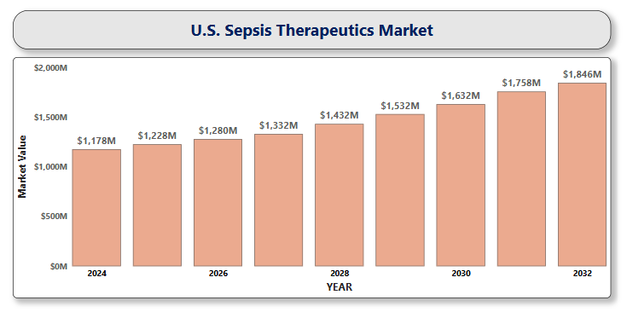

**U.S. Sickle Cell Disease Treatment Market**

**By Treatment Type** (Pharmacotherapy, Blood Transfusions, Bone Marrow/Stem Cell Transplantation, Gene Therapy, Supportive Care), **By Disease Type** (Sickle Cell Anemia, Sickle Hemoglobin-C Disease, Sickle Beta-Plus Thalassemia, Sickle Beta-Zero Thalassemia), **By Route of Administration** (Oral, Intravenous, Subcutaneous), **By Distribution Channel** (Hospital Pharmacies, Retail Pharmacies, Online Pharmacies), **And by Region/Country.** Global and Regional Industry Overview, Market Intelligence, Comprehensive Analysis, Historical Data, and Forecasts 2024 – 2032

According to Intelli, the U.S. Sickle Cell Disease Treatment Market size was valued at USD 825.33 Million in 2024 and is projected to reach USD 3,556.78 Million by 2032, growing at a compound annual growth rate (CAGR) of 20.84%, during the forecast period of 2024 to 2032.

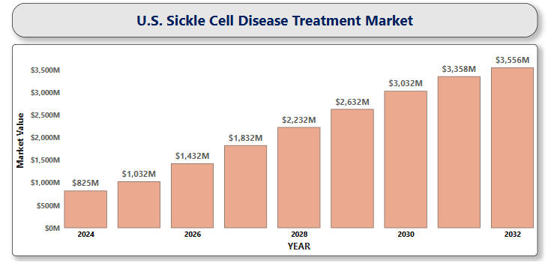

**U.S. Sleep Apnea Device Market**

**By Product Type** (Diagnostic Devices, Therapeutic Devices), **By Age Population** (Below 40 Years, 40–60 Years, Above 60 Years), **By End-Users** (Hospitals and Sleep Labs, Home Care), **And by Region/Country.** Global and Regional Industry Overview, Market Intelligence, Comprehensive Analysis, Historical Data, and Forecasts 2024 – 2032

According to Intelli, the U.S. Sleep Apnea Device Market size was valued at USD 2,150 Million in 2024 and is projected to reach USD 3,667.79 million by 2032, growing at a compound annual growth rate (CAGR) of 7.43%, during the forecast period of 2024 to 2032.

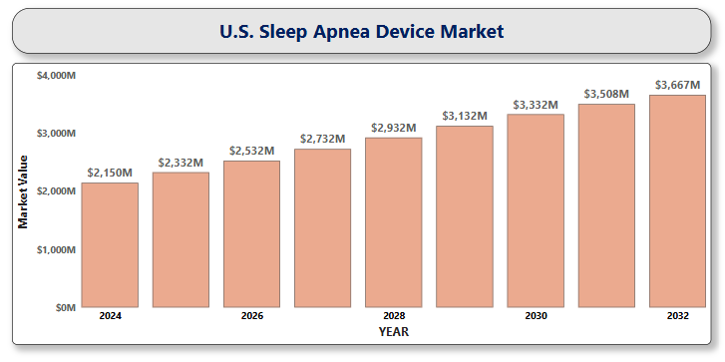

**U.S. Smart Inhalers Market**

**By Product Type** (Metered Dose Inhalers, Dry Powder Inhalers, Nebulizers), **By Application** (Asthma, Chronic Obstructive Pulmonary Disease), **By Distribution Channel** (Hospital Pharmacies, Retail Pharmacies, Online Channels), **And by Region/Country.** Global and Regional Industry Overview, Market Intelligence, Comprehensive Analysis, Historical Data, and Forecasts 2024 – 2032

According to Intelli, the U.S. Smart Inhalers Market size was valued at USD 3,571.45 Million in 2024 and is projected to reach USD 9,831.37 Million by 2032, growing at a compound annual growth rate (CAGR) of 14.37%, during the forecast period of 2024 to 2032.

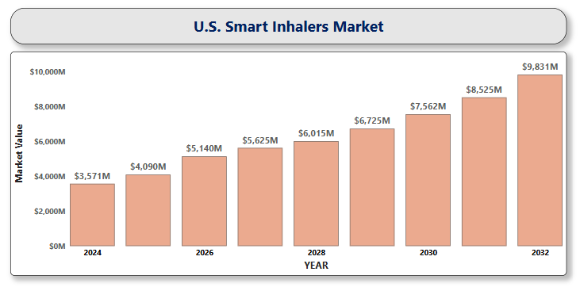

**U.S. Specialty Generics Market**

**By Drug Type** (Injectable Specialty Generics, Oral Solids, Inhalable Drugs, Ophthalmic Products, Topical Formulations, Transdermal Patches), **By Therapeutic Area** (Oncology, Autoimmune Diseases, Neurology, Cardiovascular Diseases, Respiratory Disorders, Endocrinology, Infectious Diseases, Biosimilars), **By Distribution Channel** (Hospital Pharmacies, Retail Pharmacies, Online Pharmacies, Specialty Clinics & Outpatient Centers), **By End User** (Hospitals, Specialty Clinics, Ambulatory Surgical Centers, Homecare Settings), **And by Region/Country.** Global and Regional Industry Overview, Market Intelligence, Comprehensive Analysis, Historical Data, and Forecasts 2024 – 2032

According to Intelli, the U.S. Specialty Generics Market size was valued at USD 33,550 Million in 2024 and is projected to reach USD 62,446.04 Million by 2032, growing at a compound annual growth rate (CAGR) of 8.50%, during the forecast period of 2024 to 2032.

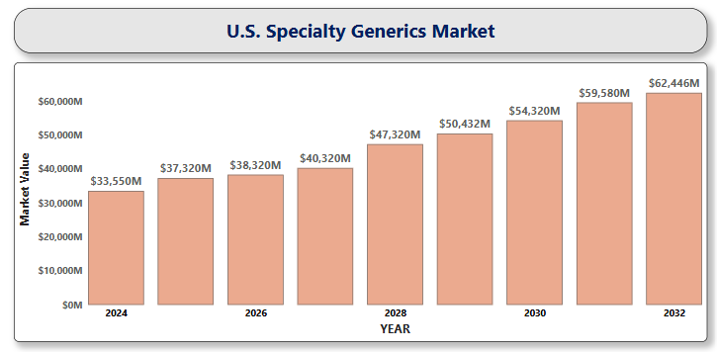

**U.S. Stomach Cancer Treatment Market**

**By Treatment Type** (Chemotherapy, Targeted Therapy, Immunotherapy, Radiation Therapy, Surgery), **By Drug Class** (HER2 Antagonists, PD-1/PD-L1 Inhibitors, VEGFR2 Antagonists), **By Route of Administration** (Injectable, Oral), **By End User** (Hospitals, Clinics, Ambulatory Surgical Centers, Specialized Cancer Treatment Centers), **And by Region/Country.** Global and Regional Industry Overview, Market Intelligence, Comprehensive Analysis, Historical Data, and Forecasts 2024 – 2032

According to Intelli, the U.S. Stomach Cancer Treatment Market size was valued at USD 1,038.65 Million in 2024 and is projected to reach USD 2,950.32 Million by 2032, growing at a compound annual growth rate (CAGR) of 14.36%, during the forecast period of 2024 to 2032.

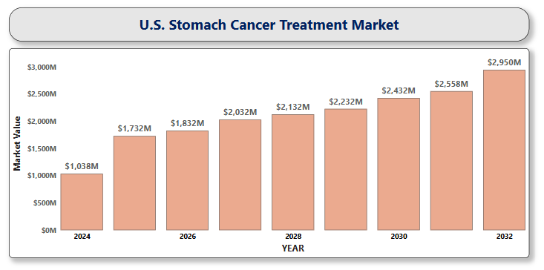

**U.S. Thyroid Cancer Diagnostics Market**

**By Diagnostic Type** (Imaging Techniques, Biopsy, Molecular Diagnostics, Blood Tests), **By Technology** (Ultrasound Imaging, Liquid Biopsy, Next-Generation Sequencing, Artificial Intelligence), **By End-User** (Hospitals, Diagnostic Laboratories, Cancer Research Institutes), **And by Region/Country.** Global and Regional Industry Overview, Market Intelligence, Comprehensive Analysis, Historical Data, and Forecasts 2024 – 2032

According to Intelli, the U.S. Thyroid Cancer Diagnostics Market size was valued at USD 1,037.42 Million in 2024 and is projected to reach USD 1,554.41 Million by 2032, growing at a compound annual growth rate (CAGR) of 5.71%, during the forecast period of 2024 to 2032.

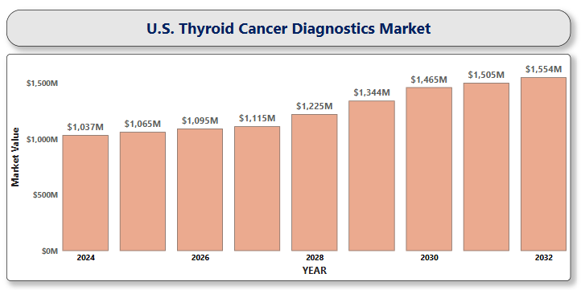

**U.S. Tuberculosis Therapeutics Market**

**By Disease Type** (Active TB, Latent TB), **By Therapy** (First-Line Therapy, Second-Line Therapy), **By Route of Administration** (Oral, Parenteral, Others), **By Distribution Channel** (Hospital Pharmacy, Retail Pharmacy, Online Pharmacy), **And by Region/Country.** Global and Regional Industry Overview, Market Intelligence, Comprehensive Analysis, Historical Data, and Forecasts 2024 – 2032

According to Intelli, the U.S. Tuberculosis Therapeutics Market size was valued at USD 150.2 Million in 2024 and is projected to reach USD 214.41 Million by 2032, growing at a compound annual growth rate (CAGR) of 4.97%, during the forecast period of 2024 to 2032.

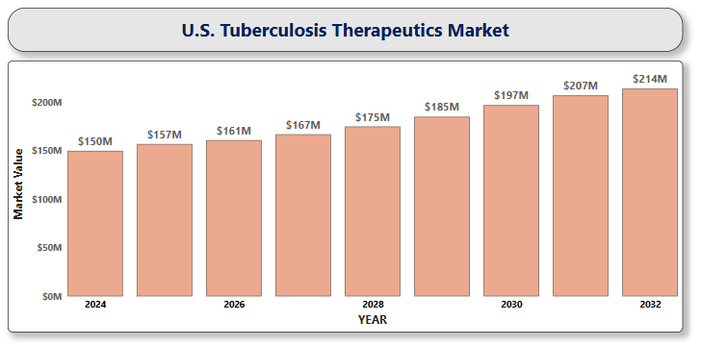

**U.S. Vagus nerve stimulation market**

**By Product Type** (Implantable VNS Devices, External (Non-Invasive) VNS Devices) **By Application** (Epilepsy, Depression, Migraine & Cluster Headaches, Inflammatory Conditions) **By End-User** (Hospitals & Surgical Centers, Specialty Clinics, Homecare Settings), **And by Region/Country.** Global and Regional Industry Overview, Market Intelligence, Comprehensive Analysis, Historical Data, and Forecasts 2024 – 2032

According to Intelli, the U.S. Vagus nerve stimulation market size was valued at USD 273.95 Million in 2024 and is projected to reach USD 555.33 million by 2032, growing at a compound annual growth rate (CAGR) of 9.76%, during the forecast period of 2024 to 2032.

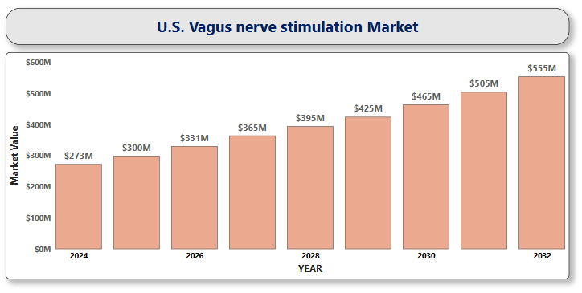

**U.S. Wearable Artificial Kidney Market**

**By Patient Type** (Acute Renal Disease, Chronic Kidney Disease (CKD) / End-Stage Renal Disease (ESRD)) **By Dialysis Type** (Hemodialysis, Peritoneal Dialysis) **By End User** (Hospitals, Dialysis Centers, Ambulatory Surgical Centers, Home Care Settings), **And by Region/Country.** Global and Regional Industry Overview, Market Intelligence, Comprehensive Analysis, Historical Data, and Forecasts 2024 – 2032

According to Intelli, the U.S. Wearable Artificial Kidney Market size was valued at USD 190.25 Million in 2024 and is projected to reach USD 311.31million by 2032, growing at a compound annual growth rate (CAGR) of 7.05%, during the forecast period of 2024 to 2032.

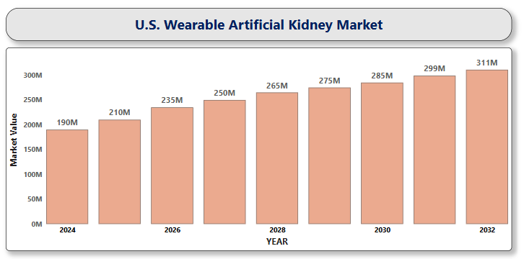

**U.S. Wearable Brain Devices Market**

**By Channel Type** (5-Channel Devices, 12-Channel Devices, 14-Channel Devices, 32-Channel Devices, Multi-Channel Devices) **By Application** (Epilepsy, Parkinson’s Disease, Alzheimer’s Disease, Traumatic Brain Injury, Sleep Disorders, Others) **By Technology** (Electroencephalography (EEG)-based Wearables, Vagus Nerve Stimulation (VNS) Devices, Deep Brain Stimulation (DBS) Interfaces, Transcranial Direct Current Stimulation (tDCS), Responsive Neurostimulation (RNS) Systems) **By End-User** (Hospitals & Clinics, Neurology Centers, Diagnostic Centers, Ambulatory Surgery Centers, Intensive Care Units, Homecare Settings), **And by Region/Country.** Global and Regional Industry Overview, Market Intelligence, Comprehensive Analysis, Historical Data, and Forecasts 2024 – 2032

According to Intelli, the U.S. Wearable Brain Devices Market size was valued at USD 165.47 Million in 2024 and is projected to reach USD 408.52 Million by 2032, growing at a compound annual growth rate (CAGR) of 12.38%, during the forecast period of 2024 to 2032.

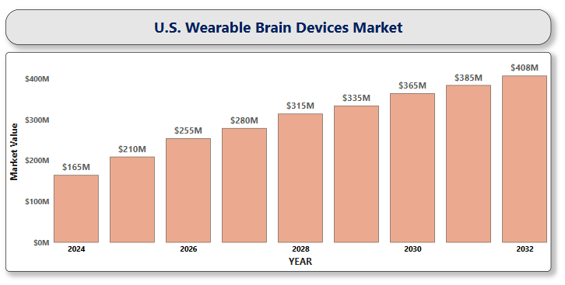

**U.S. Wearable Injectors Market**

**By Type** (On-body Wearable Injectors, Off-body Wearable Injectors) **By Application** (Autoimmune Diseases, Infectious Diseases, Cardiovascular Diseases, Oncology, Others) **By Technology** (Spring-based, Motor-driven, Expanding Battery, Rotary Pump) **By End User** (Hospitals and Clinics, Home Care, Others), **And by Region/Country.** Global and Regional Industry Overview, Market Intelligence, Comprehensive Analysis, Historical Data, and Forecasts 2024 – 2032

According to Intelli, the U.S. Wearable Injectors Market size was valued at USD 4,097.03 Million in 2024 and is projected to reach USD 9,602.50 Million by 2032, growing at a compound annual growth rate (CAGR) of 11.76%, during the forecast period of 2024 to 2032.

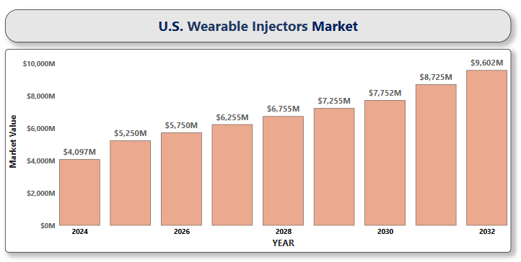

**U.S. Women’s Health App Market**

**By Application Type** (Menstrual Health & Ovulation Tracking, Fertility & Pregnancy Tracking, Fitness & Nutrition, Mental Health & Well-being, Menopause Management, Chronic Condition & Disease Management) **By Age Group** (Teenagers & Young Adults, Adults (20–40 years), Middle-aged (40–55 years), Older Women (55+ years)) **By Distribution Channel** (Healthcare Provider Portals, Direct-to-Consumer Platforms), **And by Region/Country.** Global and Regional Industry Overview, Market Intelligence, Comprehensive Analysis, Historical Data, and Forecasts 2024 – 2032

According to Intelli, the U.S. Women’s Health App Market size was valued at USD 1,476.65 Million in 2024 and is projected to reach USD 4,923 Million by 2032, growing at a compound annual growth rate (CAGR) of 17.12%, during the forecast period of 2024 to 2032.

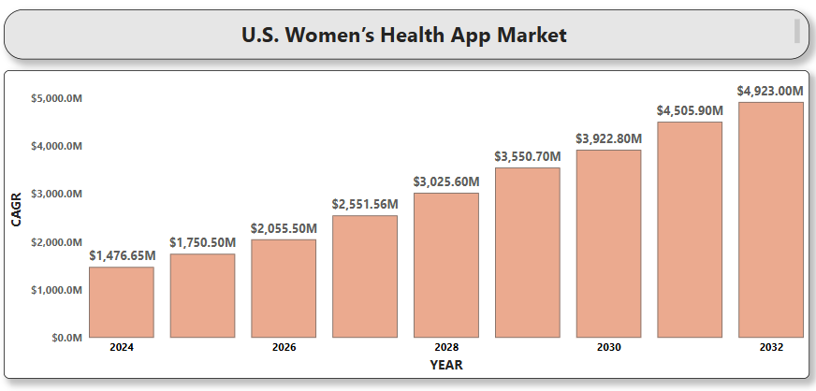

**U.S. Kidney Function Tests Market**

**By Test Type** (Blood Tests, Urine Tests), **By Product Type** (Reagents & Kits, Instruments & Analyzers, Software & Services), **By End User** (Hospitals, Diagnostic Laboratories, Ambulatory Surgical Centers (ASCs), Home Care Settings), **And by Region/Country.** Global and Regional Industry Overview, Market Intelligence, Comprehensive Analysis, Historical Data, and Forecasts 2024 – 2032

According to Intelli, the U.S. Kidney Function Tests Market size was valued at USD 305.89 Million in 2024 and is projected to reach USD 485.86 Million by 2032, growing at a compound annual growth rate (CAGR) of 6.45%, during the forecast period of 2024 to 2032.

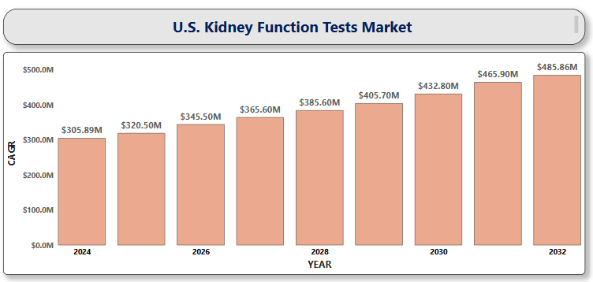

**U.S. Non-alcoholic Steatohepatitis Biomarkers Market**

**By Biomarker Type** (Liver Enzymes, Fibrosis Markers, Cytokeratin-18 Fragments, Liver Stiffness Measurement (LSM), Metabolomic and Genetic Markers), **By Diagnostic Technique** (Non-invasive Blood Tests, Liver Biopsy, Imaging Techniques), **By End-User** (Hospitals, Diagnostic Laboratories, Research Institutes), **And by Region/Country.** Global and Regional Industry Overview, Market Intelligence, Comprehensive Analysis, Historical Data, and Forecasts 2024 – 2032

According to Intelli, the U.S. Non-alcoholic Steatohepatitis Biomarkers Market size was valued at USD 732.28 Million in 2024 and is projected to reach USD 3,832.48 Million by 2032, growing at a compound annual growth rate (CAGR) of 23.48%, during the forecast period of 2024 to 2032.

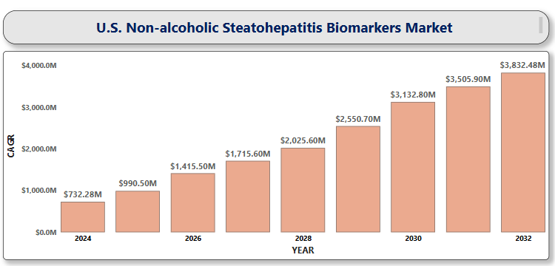

**U.S. Multi Cancer Early Detection Market**

**By Test Type** (Gene Panels, Laboratory Developed Tests, Liquid Biopsy, Others), **By Technology** (Next-Generation Sequencing (NGS), Polymerase Chain Reaction (PCR)), **By Sample Type** (Blood, Saliva and Buccal Swab), **By End User** (Hospitals, Diagnostic Laboratories, Others), **And by Region/Country.** Global and Regional Industry Overview, Market Intelligence, Comprehensive Analysis, Historical Data, and Forecasts 2024 – 2032

According to Intelli, the U.S. Multi Cancer Early Detection Market size was valued at USD 399.9 Million in 2024 and is projected to reach USD 1,377.99 Million by 2032, growing at a compound annual growth rate (CAGR) of 17.22%, during the forecast period of 2024 to 2032.

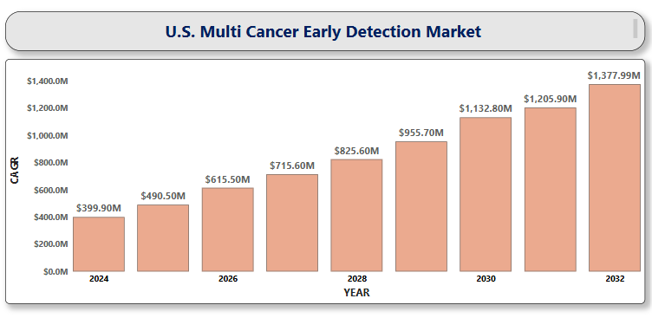

**U.S. Infectious Respiratory Disease Diagnostics Market**

**By Technology** (Molecular Diagnostics, Immunoassays, Microbiological Culture Techniques, Biosensors and Nanotechnology-Based Diagnostics, Next-Generation Sequencing (NGS), Artificial Intelligence and Machine Learning-Based Platforms), **By Disease Type** (COVID-19, Influenza, Tuberculosis, Respiratory Syncytial Virus, Pneumonia, Other Respiratory Pathogens), **By End User** (Hospitals and Clinics, Diagnostic Laboratories, Home Care Settings, Public Health Agencies), **And by Region/Country.** Global and Regional Industry Overview, Market Intelligence, Comprehensive Analysis, Historical Data, and Forecasts 2024 – 2032

According to Intelli, the U.S. Infectious Respiratory Disease Diagnostics Market size was valued at USD 18,874.1 Million in 2024 and is projected to reach USD 27,305.5 Million by 2032, growing at a compound annual growth rate (CAGR) of 5.22%, during the forecast period of 2024 to 2032.

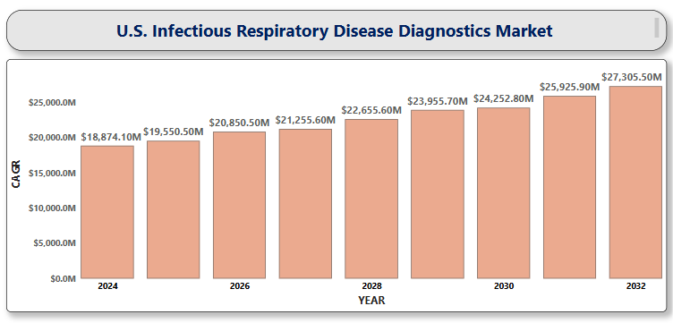

**U.S. Immunoassay for Neurological Biomarkers Market**

**By Product Type** (Reagents & Kits, Instruments, Software & Services), **By Biomarker Type** (Alzheimer’s Disease Biomarkers, Parkinson’s Disease Biomarkers, Traumatic Brain Injury (TBI) Biomarkers, Multiple Sclerosis Biomarkers, Others), **By Technology** (Enzyme-Linked Immunosorbent Assay (ELISA), Chemiluminescence Immunoassay (CLIA), Radioimmunoassay (RIA), Fluorescent Immunoassay (FIA), Others), **By End-User** (Hospitals & Clinics, Diagnostic Laboratories, Academic & Research Institutes), **And by Region/Country.** Global and Regional Industry Overview, Market Intelligence, Comprehensive Analysis, Historical Data, and Forecasts 2024 – 2032

According to Intelli, the U.S. Immunoassay for Neurological Biomarkers Market size was valued at USD 3,381.84 Million in 2024 and is projected to reach USD 8,280.74 Million by 2032, growing at a compound annual growth rate (CAGR) of 12.34%, during the forecast period of 2024 to 2032.

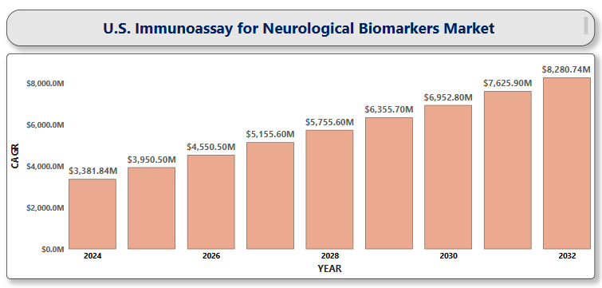

**U.S. Mycoplasma Testing Market**

**By Product Type** (Instruments, Kits & Reagents, Services), **By Technology** (PCR (Polymerase Chain Reaction), ELISA (Enzyme-Linked Immunosorbent Assay), Culture-based Testing, Nucleic Acid Amplification Techniques (NAATs), Direct Assay/Enzymatic Methods), **By End User** (Pharmaceutical and Biotechnology Companies, Contract Research Organizations (CROs), Cell Banks and Bio Manufacturers, Academic & Research Institutes), **And by Region/Country.** Global and Regional Industry Overview, Market Intelligence, Comprehensive Analysis, Historical Data, and Forecasts 2024 – 2032

According to Intelli, the U.S. Mycoplasma Testing Market size was valued at USD 360.66 Million in 2024 and is projected to reach USD 898.38 Million by 2032, growing at a compound annual growth rate (CAGR) of 12.58%, during the forecast period of 2024 to 2032.

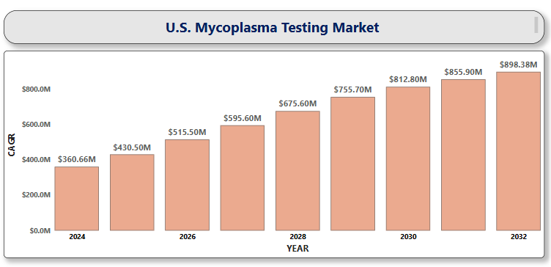

**U.S. Self-amplifying RNA Synthesis Market**

**By Product Type** (Ready-to-Use Products, Custom Synthesis Services), **By Application** (Therapeutics Development, Diagnostics, Research and Development), **By End User** (Pharmaceutical and Biotechnology Companies, Academic and Research Institutes, Contract Research Organizations (CROs)), **And by Region/Country.** Global and Regional Industry Overview, Market Intelligence, Comprehensive Analysis, Historical Data, and Forecasts 2024 – 2032

According to Intelli, the U.S. Self-amplifying RNA Synthesis Market size was valued at USD 44,998.95 Million in 2024 and is projected to reach USD 1,60,125.44 Million by 2032, growing at a compound annual growth rate (CAGR) of 17.69%, during the forecast period of 2024 to 2032.

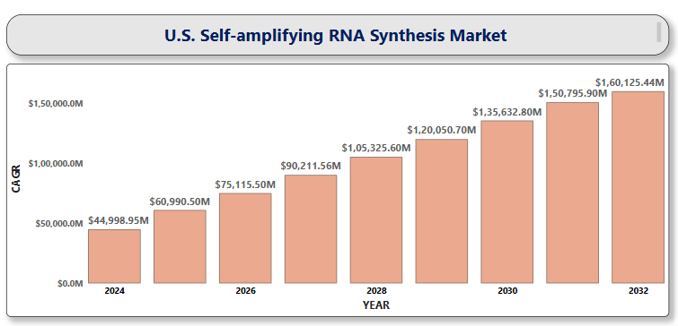

**U.S. Lipid Nanoparticle Market**

**By** Product Type (Solid Lipid Nanoparticles (SLNs), Nanostructured Lipid Carriers (NLCs), Ionizable Lipid Nanoparticles, Liposomes), **By** Payload (mRNA, siRNA, DNA, Small Molecules, Proteins & Peptides), **By** Application (Gene Therapy, Cancer Therapy, Neurological Diseases, Infectious Diseases, Vaccines), **By** End User (Pharmaceutical & Biotechnology Companies, Academic & Research Institutions, Contract Development & Manufacturing Organizations (CDMOs), Hospitals & Clinics, Contract Research Organizations (CROs)), **And by Region/Country.** Global and Regional Industry Overview, Market Intelligence, Comprehensive Analysis, Historical Data, and Forecasts 2024 – 2032

According to Intelli, the U.S. Lipid Nanoparticle Market size was valued at USD 357.95 Million in 2024 and is projected to reach USD 991.68 Million by 2032, growing at a compound annual growth rate (CAGR) of 14.08%, during the forecast period of 2024 to 2032.

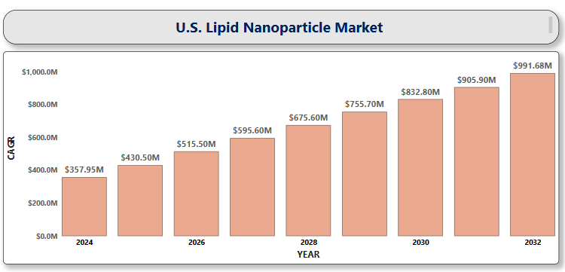

**U.S. Cell Therapy Technologies Market**

**By Product** (Consumables, Systems & Software, Equipment), **By Cell Type** (T-cells, NK Cells, Dendritic Cells, Stem Cells), **By Application** (Oncology, Cardiovascular Diseases, Orthopedic Disorders, Wound Healing, Neurological Disorders, Autoimmune Diseases), **By End User** (Research Institutes, Hospitals & Clinics, Biotechnology & Pharmaceutical Companies, Contract Research Organizations (CROs)), **And by Region/Country.** Global and Regional Industry Overview, Market Intelligence, Comprehensive Analysis, Historical Data, and Forecasts 2024 – 2032

According to Intelli, the U.S. Cell Therapy Technologies Market size was valued at USD 2,937.5 Million in 2024 and is projected to reach USD 10,303.96 Million by 2032, growing at a compound annual growth rate (CAGR) of 17.48%, during the forecast period of 2024 to 2032.

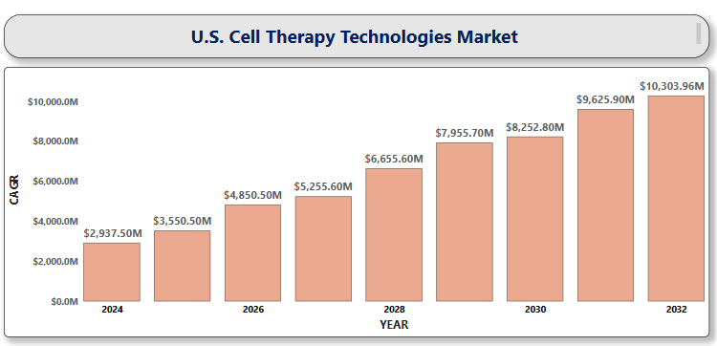

**U.S. Pulmonary Arterial Hypertension Market**

**By Drug Class** (Endothelin Receptor Antagonists (ERAs), Prostacyclin Analogs, Phosphodiesterase-5 Inhibitors (PDE-5i), Soluble Guanylate Cyclase (sGC) Stimulators, Calcium Channel Blockers, Combination Therapies), **By Route of Administration** (Oral, Subcutaneous, Intravenous, Inhalation), **By Distribution Channel** (Hospital Pharmacies, Online Pharmacies, Retail Pharmacies), **And by Region/Country.** Global and Regional Industry Overview, Market Intelligence, Comprehensive Analysis, Historical Data, and Forecasts 2024 – 2032.

According to Intelli, the U.S. Pulmonary Arterial Hypertension Market size was valued at USD 2,873.48 Million in 2024 and is projected to reach USD 3,979.52 Million by 2032, growing at a compound annual growth rate (CAGR) of 4.65%, during the forecast period of 2024 to 2032.

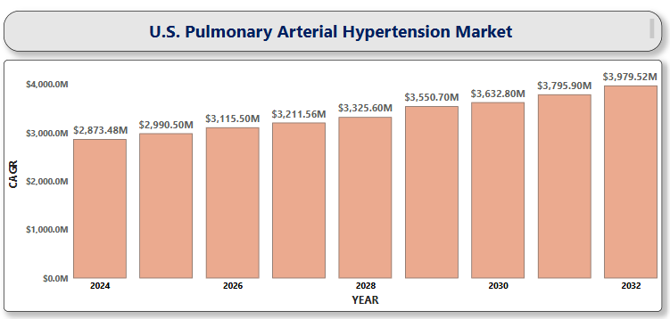

**U.S. Inflammatory Bowel Disease Treatment Market**

**By Drug Class** (Aminosalicylates (5-ASA), Biologics, Corticosteroids, Immunosuppressants, JAK Inhibitors, Others), **By Route of Administration** (Oral, Intravenous (IV)), **By Distribution Channel** (Hospital Pharmacies, Online Pharmacies, Retail Pharmacies), **And by Region/Country.** Global and Regional Industry Overview, Market Intelligence, Comprehensive Analysis, Historical Data, and Forecasts 2024 – 2032.

According to Intelli, the U.S. Inflammatory Bowel Disease Treatment Market size was valued at USD 11,657.70 Million in 2024 and is projected to reach USD 14,375.79 Million by 2032, growing at a compound annual growth rate (CAGR) of 3.15 %, during the forecast period of 2024 to 2032.

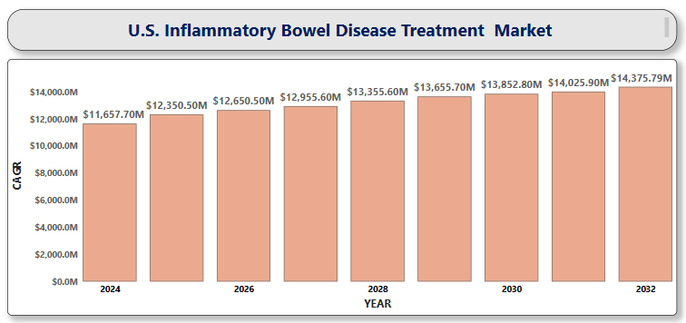

**U.S. Attention Deficit Hyperactivity Disorder**

**By Drug Type** (Stimulants, Non-stimulants), **By Age Group** (Children and Adolescents, Adults), **By Therapy Type** (Pharmacological Treatment, Behavioral Therapy, Digital Therapeutics), **By Distribution Channel** (Retail Pharmacies, Hospital Pharmacies, Online & Telehealth Platforms), **And by Region/Country.** Global and Regional Industry Overview, Market Intelligence, Comprehensive Analysis, Historical Data, and Forecasts 2024 – 2032.

According to Intelli, the U.S. Attention Deficit Hyperactivity Disorder Market size was valued at USD 10,148.41 Million in 2024 and is projected to reach USD 12,940.26 Million by 2032, growing at a compound annual growth rate (CAGR) of 3.58%, during the forecast period of 2024 to 2032.

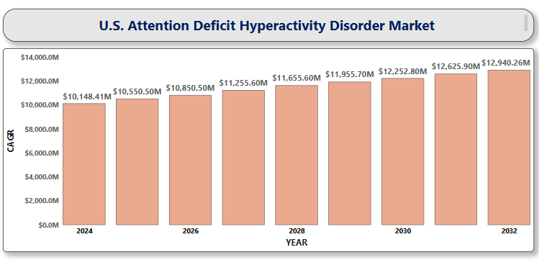

**Global Telemedicine for Sleep Disorders Market**

**By Disorder Type** (Insomnia, Obstructive Sleep Apnea (OSA), Restless Leg Syndrome (RLS), Circadian Rhythm Disorders, Narcolepsy), **By Component** (Services, Software, Hardware), **By Technology** (Store-and-Forward (Asynchronous), Real-time (Synchronous), Remote Patient Monitoring (RPM), Mobile Health (mHealth)), **By End User** (Hospitals and Sleep Clinics, Homecare Settings, Patients, Research and Academic Institutes), **By Region** (North America, Europe, Asia-Pacific, Latin America, Middle East & Africa). Global and Regional Industry Overview, Market Intelligence, Comprehensive Analysis, Historical Data, and Forecasts 2024 – 2032.

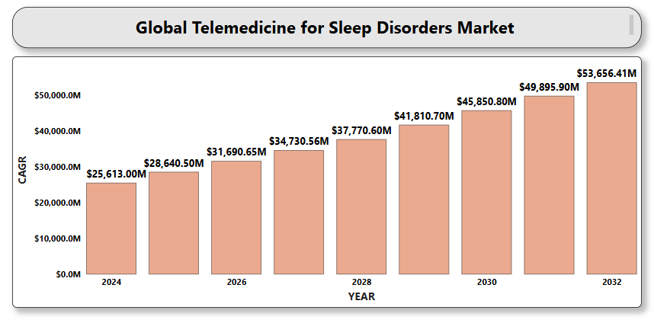

**Global Cognitive Health Supplements Market**

**By Product Type** (Natural Molecules, Herbal Extracts, Nootropics, Vitamins & Minerals), **By Form** (Capsules, Tablets, Powders, Soft gels, Liquid supplements, Gummies), **By Application** (Memory Enhancement, Attention & Focus, Mood & Stress Management, Anti-aging & Neuroprotection, Sleep & Recovery Support), **By Distribution Channel** (Pharmacies & Drug Stores, Supermarkets/Hypermarkets, Specialty Stores, Online Retail/E-commerce, Direct Sales), **By Region** (North America, Europe, Asia-Pacific, Latin America, Middle East & Africa). Global and Regional Industry Overview, Market Intelligence, Comprehensive Analysis, Historical Data, and Forecasts 2024 – 2032.

According to Intelli, the Global Cognitive Health Supplements Market size was valued at USD 8,200 Million in 2024 and is projected to reach USD 21,698.3 Million by 2032, growing at a CAGR of 13.43% during the forecast period 2024 to 2032.

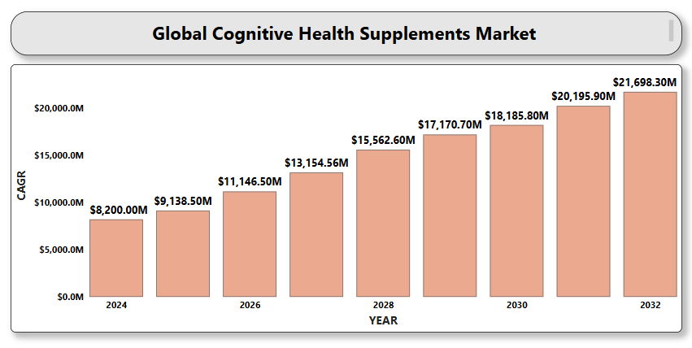

**Global Gut Health Nutraceuticals Market**

**By Product Type** (Probiotics, Prebiotics, Synbiotics, Postbiotics, Fiber Supplements, Digestive Enzymes, Polyphenols & Botanical Extracts), **By Form** (Capsules & Tablets, Powders, Liquids, Gummies & Chewables, Functional Foods & Beverages, Sachets & Stick Packs), **By End User** (Adults, Geriatric Population, Children & Adolescents, Athletes & Fitness Enthusiasts), **By Distribution Channel** (Pharmacies & Drug Stores, Supermarkets & Hypermarkets, Online Retail / E-commerce, Health & Wellness Stores, Direct-to-Consumer (D2C) Channels), **By Region** (North America, Europe, Asia-Pacific, Latin America, Middle East & Africa). Global and Regional Industry Overview, Market Intelligence, Comprehensive Analysis, Historical Data, and Forecasts 2024 – 2032.

According to Intelli, the Global Gut Health Nutraceuticals Market size was valued at USD 13.56 Billion in 2024 and is projected to reach USD 23.06 Billion by 2032, growing at a CAGR of 7.36% during the forecast period 2024 to 2032.

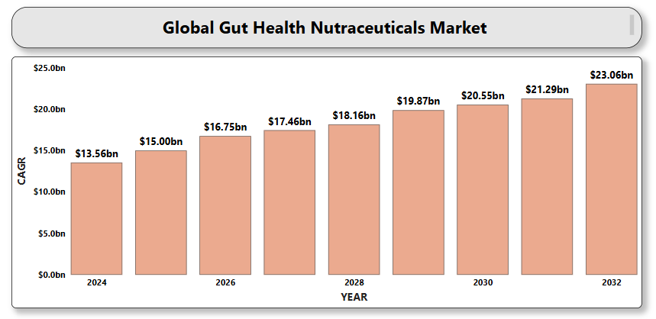

**Global Cardiovascular Health Nutraceuticals Market**

**By Product Type** (Functional Foods, Dietary Supplements, Beverages, Others) **By Ingredient Type** (Omega-3 Fatty Acids (EPA/DHA), Plant Sterols and Stanols, Antioxidants (e.g., polyphenols, flavonoids, resveratrol), Coenzyme Q10 (CoQ10), Soluble Fibers (e.g., beta-glucans), L-Carnitine, Magnesium and Potassium, Vitamins (e.g., B-complex, D, E)) **By Form** (Capsules and Tablets, Powders, Liquids, Softgels, Gummies) **By Distribution Channel** (Pharmacies and Drug Stores, Supermarkets and Hypermarkets, Online Retail (E-commerce), Direct Sales, Health & Wellness Stores) **By Region** (North America, Europe, Asia-Pacific, Latin America, Middle East & Africa). Global and Regional Industry Overview, Market Intelligence, Comprehensive Analysis, Historical Data, and Forecasts 2024 – 2032.

According to Intelli, the Global Cardiovascular Health Nutraceuticals Market size was valued at USD 10.25Billion in 2024 and is projected to reach USD 24.44 Billion by 2032, growing at a CAGR of 8.14% during the forecast period 2024 to 2032.

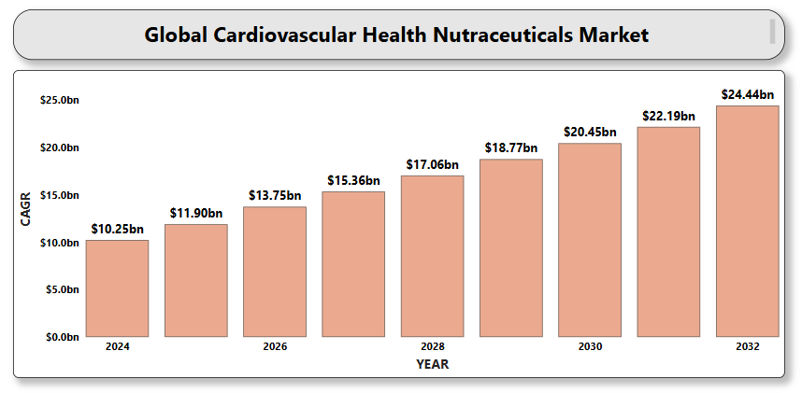

**Global Mood and Mental Health Nutraceuticals Market**

**By Product Type** (Dietary Supplements, Herbal and Botanical Extracts, Functional Foods and Beverages), **By Ingredient** (Vitamins & Minerals, Omega-3 Fatty Acids, Amino Acids, Probiotics, Adaptogens), **By Application** (Stress, Depression Support, Sleep Enhancement, Cognitive Function and Focus, Mood Stabilization, Anxiety Reduction), **By Distribution Channel** (Online Retail/E-commerce, Pharmacies and Drug Stores, Health & Wellness Stores, Supermarkets/Hypermarkets, Direct Sales and Specialty Stores), **By Region** (North America, Europe, Asia-Pacific, Latin America, Middle East & Africa). Global and Regional Industry Overview, Market Intelligence, Comprehensive Analysis, Historical Data, and Forecasts 2024 – 2032.

According to Intelli, the Global Mood and Mental Health Nutraceuticals Market size was valued at USD 737.56Million in 2024 and is projected to reach USD 1,394.2 Million by 2032, growing at a CAGR of 8.78% during the forecast period 2024 to 2032.

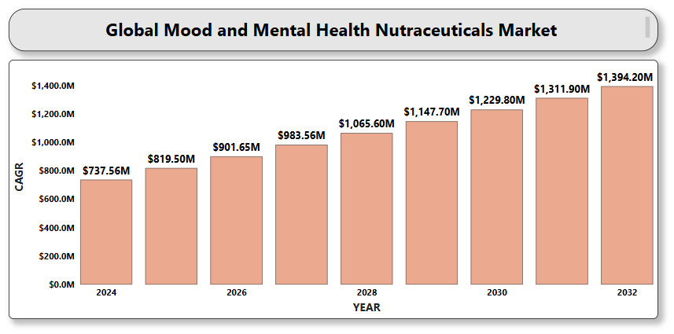

**Global Diabetes Management Nutraceuticals Market**

**By Product Type** (Dietary Supplements, Functional Foods, Functional Beverages), **By Ingredient** (Vitamins and Minerals, Herbal Extracts and Phytochemicals, Amino Acids, Prebiotics, Omega-3 Fatty Acids), **By Form** (Capsules & Tablets, Powders, Liquid & Gels, Softgels), **By Distribution Channel** (Pharmacies and Drug Stores, Supermarkets and Hypermarkets, Online Retail, Health & Wellness Stores, Direct-to-Consumer (D2C) Channels), **By Region** (North America, Europe, Asia-Pacific, Latin America, Middle East & Africa). Global and Regional Industry Overview, Market Intelligence, Comprehensive Analysis, Historical Data, and Forecasts 2024 – 2032.

According to Intelli, the Global Diabetes Management Nutraceuticals Market size was valued at USD 18,032.5 Million in 2024 and is projected to reach USD 31,342.81 Million by 2032, growing at a CAGR of 7.65% during the forecast period 2024 to 2032.

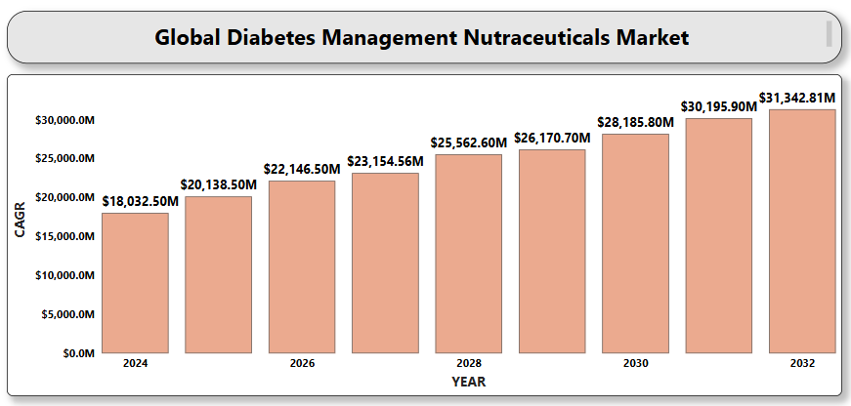

**Global Nutraceuticals for Immune Health Market**

**By Product Type** (Dietary Supplements, Functional Foods, Functional Beverages, Elderly Nutrition Products), **By Ingredient** (Vitamins, Minerals, Probiotics & Prebiotics, Amino Acids, Botanical Extracts, Omega-3 Fatty Acids), **By Form** (Capsules & Tablets, Powders, Liquids, Gummies & Chewables, Effervescent Tablets), **By Distribution Channel** (Pharmacies & Drug Stores, Supermarkets/Hypermarkets, Online Retail/E-commerce, Health & Wellness Stores, Direct-to-Consumer (DTC) Brands), **By Region** (North America, Europe, Asia-Pacific, Latin America, Middle East & Africa). Global and Regional Industry Overview, Market Intelligence, Comprehensive Analysis, Historical Data, and Forecasts 2024 – 2032.

According to Intelli, the Global Nutraceuticals for Immune Health Market size was valued at USD 29.18Billion in 2024 and is projected to reach USD 63.44 Billion by 2032, growing at a CAGR of 10.69% during the forecast period 2024 to 2032.

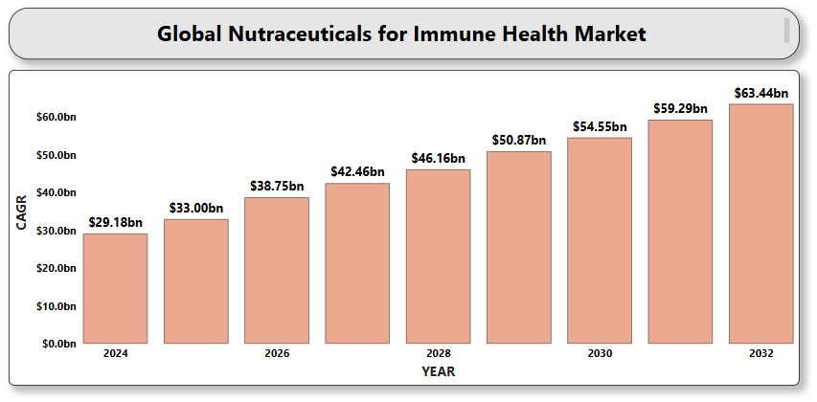

**Global Anticancer Nutraceuticals Market**

**By Product Type** (Functional Foods, Dietary Supplements, Beverages), **By Ingredient** (Phytochemicals, Vitamins & Minerals, Probiotics & Prebiotics, Omega Fatty Acids, Proteins & Amino Acids, Botanical Extracts), **By Cancer Type** (Breast Cancer, Colorectal Cancer, Prostate Cancer, Lung Cancer, Stomach/Gastric Cancer), **By Distribution Channel** (Pharmacies & Drug Stores, Health & Wellness Stores, Supermarkets/Hypermarkets, Online Retail, Direct Sales), **By Region** (North America, Europe, Asia-Pacific, Latin America, Middle East & Africa). Global and Regional Industry Overview, Market Intelligence, Comprehensive Analysis, Historical Data, and Forecasts 2024 – 2032.

According to Intelli, the Global Anticancer Nutraceuticals Market size was valued at USD 130 Million in 2024 and is projected to reach USD 205.55 Million by 2032, growing at a CAGR of 6.39% during the forecast period 2024 to 2032.

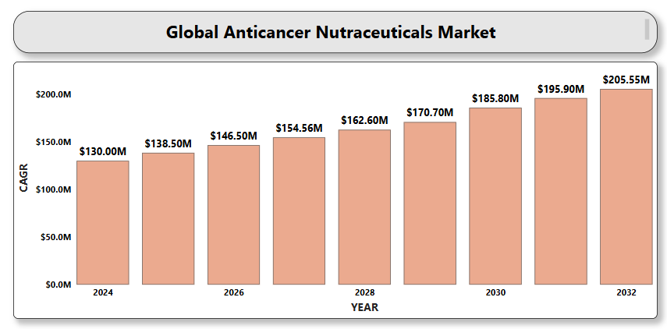

**Global Probiotics and Prebiotics Market**

**By Product Type** (Foods & Beverages, Dietary Supplements), **By Ingredient** (Probiotics: Lactobacillus, Bifidobacterium, Streptococcus, Yeast e.g., Saccharomyces boulardii; Prebiotics: Inulin, Galacto-oligosaccharides (GOS), Fructo-oligosaccharides (FOS), Resistant Starch, Other Fibers e.g., lactulose), **By Application** (Digestive Health, Immune Health, Mental Health & Mood Support, Weight Management & Metabolism, Skin Health), **By Distribution Channel** (Supermarkets/Hypermarkets, Pharmacies & Drug Stores, Online Retail, Specialty Stores, Health & Wellness Stores), **By Region** (North America, Europe, Asia-Pacific, Latin America, Middle East & Africa). Global and Regional Industry Overview, Market Intelligence, Comprehensive Analysis, Historical Data, and Forecasts 2024 – 2032.

According to Intelli, the Global Probiotics and Prebiotics Market size was valued at USD 95.92 Billion in 2024 and is projected to reach USD 361.68 Billion by 2032, growing at a CAGR of 14.14% during the forecast period 2024 to 2032.

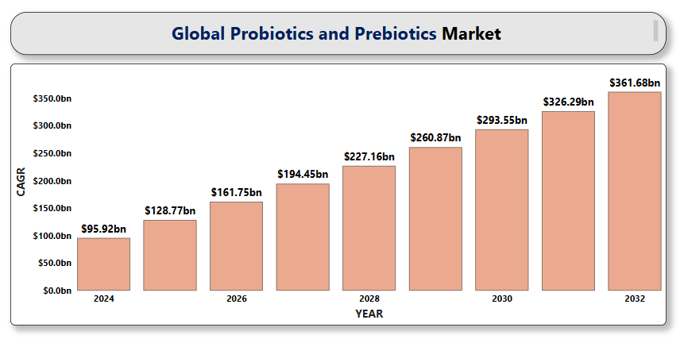

**Global Plant-Based Nutraceuticals Market**

**By** **Product Type** (Functional Foods, Dietary Supplements, Functional Beverages), **By** **Source** (Fruits & Vegetables, Herbs & Spices, Legumes & Pulses, Others), **By** **Application** (Immunity Enhancement, Digestive Health, Cardiovascular Health, Weight Management, Diabetes Management, Cognitive Health, Anti-Aging and Skin Health), **By** **Form** (Powder, Capsules & Tablets, Liquid, Gummies and Chewables, Softgels), **By Distribution Channel** (Retail Pharmacies, Online Platforms, Supermarkets/Hypermarkets, Specialty Stores, Health & Wellness Stores), **By** **Region** (North America, Europe, Asia-Pacific, Latin America, Middle East & Africa). Global and Regional Industry Overview, Market Intelligence, Comprehensive Analysis, Historical Data, and Forecasts 2024 – 2032.

According to Intelli, the Global Plant-Based Nutraceuticals Market size was valued at USD 21.12 Billion in 2024 and is projected to reach USD 36.92 Billion by 2032, growing at a CAGR of 7.73% during the forecast period 2024 to 2032.

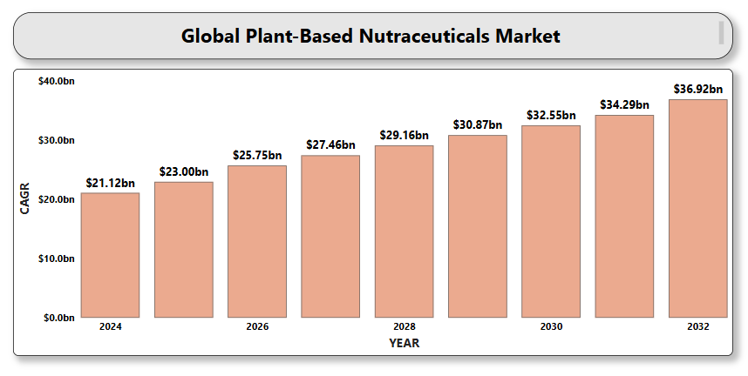

**Global Bone and Joint Health Supplements Market**

**By Ingredient Type** (Calcium, Vitamin D, Collagen, Magnesium, Glucosamine, Chondroitin, Omega-3 Fatty Acids, Others), **By Supplement Form** (Tablets, Capsules, Powders, Liquids, Gummies, Softgels), **By Application** (Osteoporosis, Arthritis, Joint Pain & Inflammation, Bone Fractures & Injuries, General Bone and Joint Maintenance), **By Distribution Channel** (Pharmacies & Drug Stores, Supermarkets & Hypermarkets, Health & Wellness Stores, Online Retailers), **By Region** (North America, Europe, Asia-Pacific, Latin America, Middle East & Africa). Global and Regional Industry Overview, Market Intelligence, Comprehensive Analysis, Historical Data, and Forecasts 2024 – 2032.

According to Intelli, the Global Bone and Joint Health Supplements Market size was valued at USD 4.52 Billion in 2024 and is projected to reach USD 7.55 Billion by 2032, growing at a CAGR of 7.12% during the forecast period 2024 to 2032.

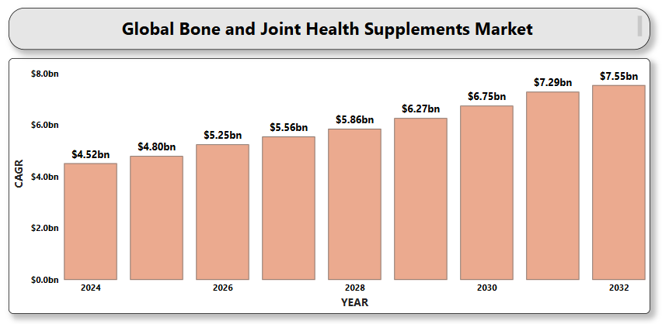

**Global Eye Health Nutraceuticals Market**

**By Ingredient** (Lutein and Zeaxanthin Supplements, Omega-3 Fatty Acid Supplements, Antioxidant Vitamins, Herbal Extracts, Multinutrient Formulations), **By Form** (Tablets, Capsules, Softgels, Powders, Liquid Drops, Gummies & Chewables), **By Indication** (Age-related Macular Degeneration (AMD), Dry Eye Syndrome, Diabetic Retinopathy, Cataracts, Glaucoma), **By Distribution Channel** (Pharmacies & Drug Stores, Supermarkets & Hypermarkets, Online Retail / E-commerce Platforms, Health & Wellness Stores, Hospitals & Clinics), **By Region** (North America, Europe, Asia-Pacific, Latin America, Middle East & Africa). Global and Regional Industry Overview, Market Intelligence, Comprehensive Analysis, Historical Data, and Forecasts 2024 – 2032.

According to Intelli, the Global Eye Health Nutraceuticals Market size was valued at USD 6,170 Million in 2024 and is projected to reach USD 12,887.81 Million by 2032, growing at a CAGR of 10.14% during the forecast period 2024 to 2032.

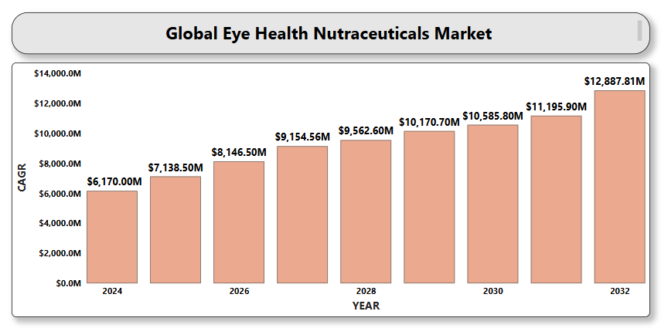

**Global Protein and Amino Acid Supplements Market**

**By Product Type** (Protein Supplements: Whey Protein, Casein Protein, Soy Protein, Pea Protein; Amino Acid Supplements: Branched-Chain Amino Acids (BCAAs), Essential Amino Acids (EAAs), Glutamine, Arginine), **By Form** (Powder, Capsules & Tablets, Ready-to-Drink (RTD), Bars, Others), **By Application** (Sports Nutrition, Clinical Nutrition, Functional Food & Beverages, Weight Management, Others), **By Distribution Channel** (Supermarkets/Hypermarkets, Specialty Stores (health stores, pharmacies), Online Retail (e-commerce), Direct Sales, Others), **By Region** (North America, Europe, Asia-Pacific, Latin America, Middle East & Africa). Global and Regional Industry Overview, Market Intelligence, Comprehensive Analysis, Historical Data, and Forecasts 2024 – 2032.

According to Intelli, the Global Protein and Amino Acid Supplements Market size was valued at USD 26.34 Billion in 2024 and is projected to reach USD 48.33 Billion by 2032, growing at a CAGR of 8.38% during the forecast period 2024 to 2032.

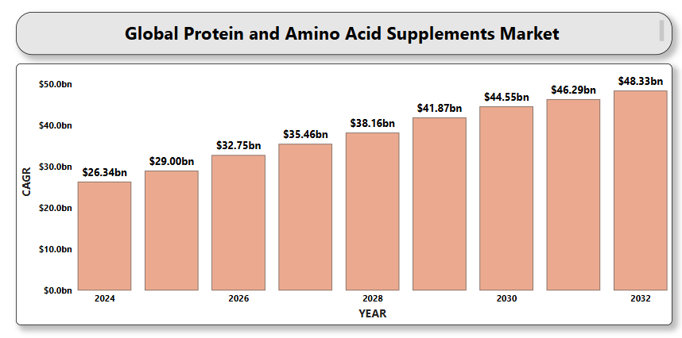

**Global Personalized Nutrition Market**

**By Product Type** (Active Measurement Products), (Standard Measurement Products), (Personalized Nutrition Plans & Services), (Personalized Supplements & Functional Foods),

**By Application** (General Wellness & Preventive Care), (Sports & Fitness Nutrition), (Diabetes Management), (Cardiovascular Health), (Digestive Health), **By End-User** (Direct-to-Consumer), (Healthcare Providers), (Fitness & Wellness Centers), (Corporate Wellness Programs), **By Form** (Tablets & Capsules), (Soft Gels), (Powders), (Liquids), **By Region** (North America), (Europe), (Asia-Pacific), (Latin America), (Middle East & Africa). Global and Regional Industry Overview, Market Intelligence, Comprehensive Analysis, Historical Data, and Forecasts 2024 – 2032.

According to Intelli, the Global Personalized Nutrition Market size was valued at USD 14.06 Billion in 2024 and is projected to reach USD 40.91 Billion by 2032, growing at a CAGR of 14.78% during the forecast period 2024 to 2032.

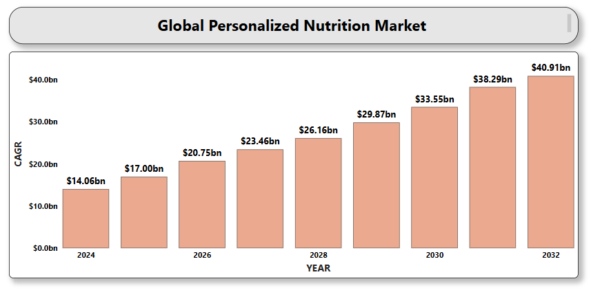

**Global Skin Health Supplements Market**

**By** **Ingredient Type** (Vitamins, Minerals, Collagen, Hyaluronic Acid, Probiotics, Omega Fatty Acids, Plant Extracts), **By** **Form** (Powder, Liquids, Softgels, Tablets, Capsules), **By** **Application** (Anti-aging, Skin Hydration, Acne Treatment, Scar Treatment and Skin Repair), **By** End User (Men, Women), **By** **Distribution Channel** (Pharmacies/Drug Stores, Supermarkets/Hypermarkets, Online Retail, Health & Beauty Stores, Direct Sales), **By** **Region** (North America, Europe, Asia-Pacific, Latin America, Middle East & Africa). Global and Regional Industry Overview, Market Intelligence, Comprehensive Analysis, Historical Data, and Forecasts 2024 – 2032.

According to Intelli, the Global Skin Health Supplements Market size was valued at USD 4.005 Billion in 2024 and is projected to reach USD 7.21 Billion by 2032, growing at a CAGR of 8.14 % during the forecast period 2024 to 2032.

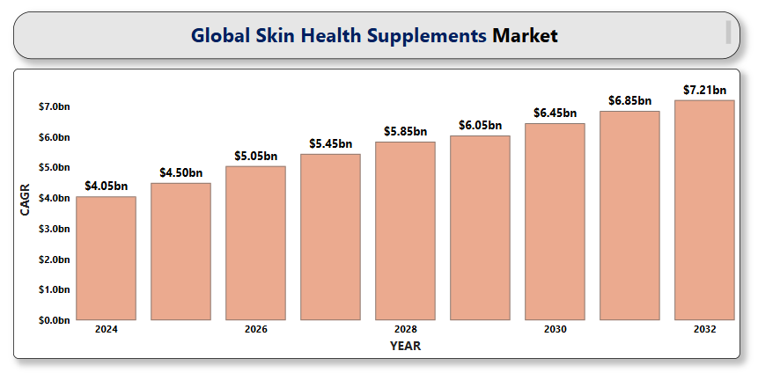

**Global AI-Driven Telemedicine Market**

**By** **Component** (Software: AI diagnostic tools, Virtual assistants & chatbots, Predictive analytics platforms, EHR-integrated AI solutions; Hardware: IoT-enabled monitoring systems, Wearable health devices, Telemedicine kits), **By** **Technology** (Machine Learning (ML), Natural Language Processing (NLP), Computer Vision, Speech Recognition), **By** **Application** (Diagnosis & Triage Support, Remote Monitoring & Chronic Disease Management, Mental Health Services, Medication Management, Virtual Consultations, Post-operative Care), **By** **End User** (Hospitals & Clinics, Diagnostic Centers, Homecare Settings), **By** **Region** (North America, Europe, Asia-Pacific, Latin America, Middle East & Africa). Global and Regional Industry Overview, Market Intelligence, Comprehensive Analysis, Historical Data, and Forecasts 2024 – 2032.

According to Intelli, the Global AI-Driven Telemedicine Market size was valued at USD 19.56 Billion in 2024 and is projected to reach USD 121.87 Billion by 2032, growing at a CAGR of 26.19% during the forecast period 2024 to 2032.

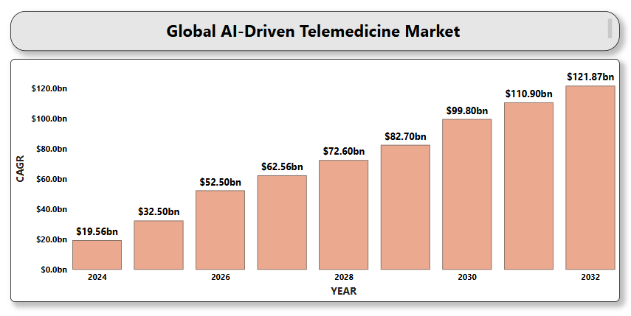

**Global Liquid Dietary Supplements Market**

**By Ingredient** (Vitamins, Minerals, Botanicals/Herbal Extracts, Enzymes, Omega Fatty Acids, Proteins & Amino Acids), **By Application** (General Health & Wellness, Bone & Joint Health, Heart Health, Immune Health, Weight Loss & Metabolism, Digestive Health, Prenatal Health), **By End User** (Adults, Geriatric Population, Children, Infants, Pregnant Women), **By Distribution Channel** (Online Retailers (E-commerce), Pharmacies & Drug Stores, Supermarkets & Hypermarkets, Specialty Stores, Direct Sales), **By Region** (North America, Europe, Asia-Pacific, Latin America, Middle East & Africa). Global and Regional Industry Overview, Market Intelligence, Comprehensive Analysis, Historical Data, and Forecasts 2024 – 2032.

According to Intelli, the Global Liquid Dietary Supplements Market size was valued at USD 24.83 Billion in 2024 and is projected to reach USD 51.86 Billion by 2032, growing at a CAGR of 10.14% during the forecast period 2024 to 2032.

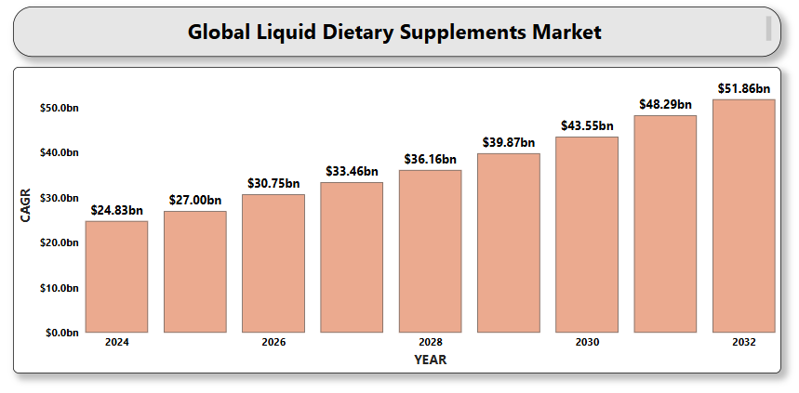

**Global Collagen-Based Nutraceuticals Market**

**By Source** (Bovine Collagen, Marine Collagen, Porcine Collagen, Others), **By Form** (Powders, Capsules & Tablets, Gummies & Chewables), **By Application** (Beauty & Personal Care, Joint & Bone Health, Sports Nutrition, General Health & Wellness), **By Distribution Channel** (Pharmacies & Drug Stores, Supermarkets & Hypermarkets, Specialty Stores, Online Retail, Others), **By Region** (North America, Europe, Asia-Pacific, Latin America, Middle East & Africa). Global and Regional Industry Overview, Market Intelligence, Comprehensive Analysis, Historical Data, and Forecasts 2024 – 2032.

According to Intelli, the Global Collagen-Based Nutraceuticals Market size was valued at USD 2.93 Billion in 2024 and is projected to reach USD 4.16 Billion by 2032, growing at a CAGR of 4.98% during the forecast period 2024 to 2032.

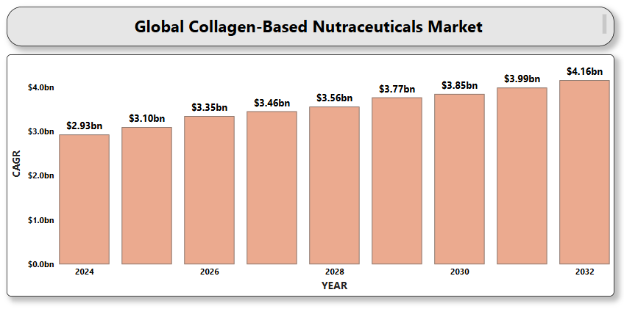

**Global Green Tea Extracts and Supplements Market**

**By Form** (Green Tea Extract Capsules & Tablets, Green Tea Extract Powder, Green Tea Extract Liquid, Others), **By Application** (Dietary Supplements, Functional Foods & Beverages, Personal Care & Cosmetics, Pharmaceuticals, Others), **By Distribution Channel** (Supermarkets/Hypermarkets, Specialty Stores, Online Retail, Pharmacies & Drugstores, Direct Sales), **By Region** (North America, Europe, Asia-Pacific, Latin America, Middle East & Africa). Global and Regional Industry Overview, Market Intelligence, Comprehensive Analysis, Historical Data, and Forecasts 2024 – 2032.

According to Intelli, the Global Green Tea Extracts and Supplements Market size was valued at USD 850.5 Million in 2024 and is projected to reach USD 1,197 Million by 2032, growing at a CAGR of 4.86% during the forecast period 2024 to 2032.

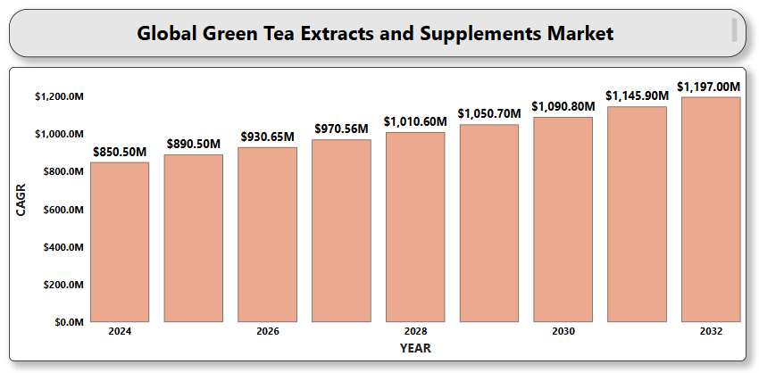

**Global Detox and Cleanse Supplements Market**

**By Product Type** (Tablets & Capsules, Powders, Teas & Herbal Infusions, Gummies, Liquids & Tonics), **By Ingredient Type** (Herbal Extracts, Dietary Fibers, Probiotics & Prebiotics, Vitamins and Minerals, Antioxidants and Superfoods), **By Application** (Liver Detoxification, Colon and Digestive Tract Cleansing, Kidney Support, Skin Health and Radiance, Weight Management and Metabolism Boosting, Full Body Detox), **By Distribution Channel** (Online Retailers and E-commerce Platforms, Pharmacies and Drug Stores, Supermarkets/Hypermarkets, Health & Wellness Stores), **By Region** (North America, Europe, Asia-Pacific, Latin America, Middle East & Africa). Global and Regional Industry Overview, Market Intelligence, Comprehensive Analysis, Historical Data, and Forecasts 2024 – 2032.

According to Intelli, the Global Detox and Cleanse Supplements Market size was valued at USD 65.61 Billion in 2024 and is projected to reach USD 100.87 Billion by 2032, growing at a CAGR of 6.02% during the forecast period 2024 to 2032.

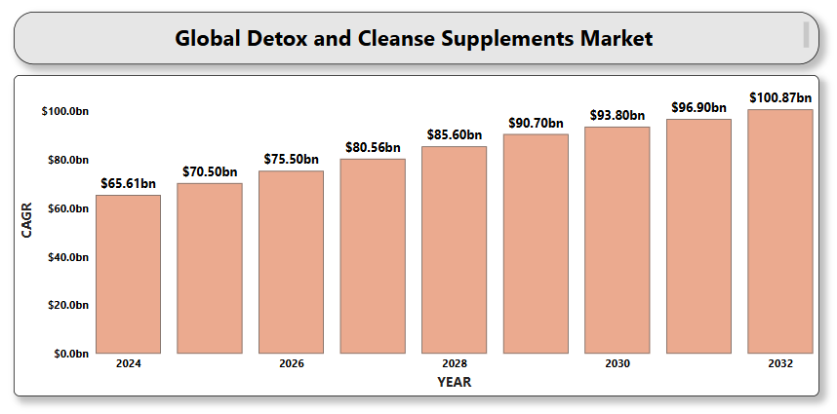

**Global Vitamins and Mineral Supplements Market**

**By Product Type** (Vitamins: Single Vitamin, Multivitamins; Minerals: Single Mineral, Multimineral), **By Form** (Tablets, Capsules, Powders, Gummies, Softgels, Liquids, Effervescent tablets), **By Application** (General Health & Wellness, Immunity Support, Bone & Joint Health, Heart Health, Cognitive Health, Energy & Endurance, Digestive Health, Beauty/Anti-aging), **By End User** (Adults, Geriatric Population, Children & Adolescents, Pregnant Women), **By Distribution Channel** (Pharmacies & Drug Stores, Supermarkets/Hypermarkets, Online Retail/E-commerce, Health & Wellness Stores), **By Region** (North America, Europe, Asia-Pacific, Latin America, Middle East & Africa). Global and Regional Industry Overview, Market Intelligence, Comprehensive Analysis, Historical Data, and Forecasts 2024 – 2032.

According to Intelli, the Global Vitamins and Mineral Supplements Market size was valued at USD 25.83 Billion in 2024 and is projected to reach USD 39.23 Billion by 2032, growing at a CAGR of 5.52 % during the forecast period 2024 to 2032.

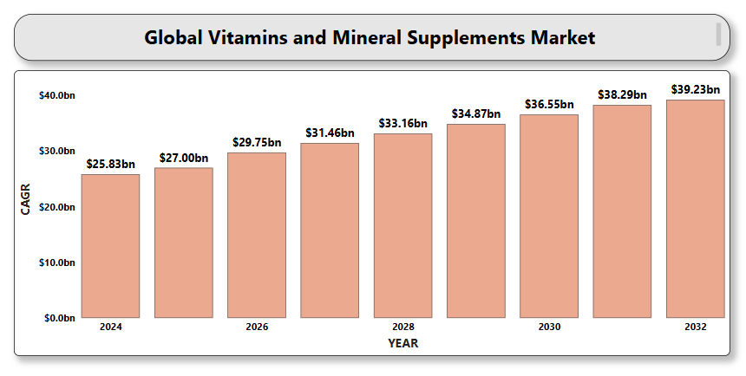

**Global Children’s Nutritional Supplements Market**

**By** **Product Type** (Vitamins, Minerals, Omega-3 & Fatty Acids, Probiotics, Proteins & Amino Acids, Herbal and Natural Supplements, Others), **By Form** (Gummies, Chewable Tablets, Syrups, Powders, Effervescent Tablets, Capsules, Liquids and Drops), **By** **Sales Channel** (Pharmacies and Drug Stores, Supermarkets and Hypermarkets, Online Retail / E-commerce, Health & Wellness Stores, Pediatric Clinics and Hospitals, Direct Sales), **By** **Region** (North America, Europe, Asia-Pacific, Latin America, Middle East & Africa). Global and Regional Industry Overview, Market Intelligence, Comprehensive Analysis, Historical Data, and Forecasts 2024 – 2032.

According to Intelli, the Global Children's Nutritional Supplements Market size was valued at USD 4.45 Billion in 2024 and is projected to reach USD 6.28 Billion by 2032, growing at a CAGR of 4.91% during the forecast period 2024 to 2032.

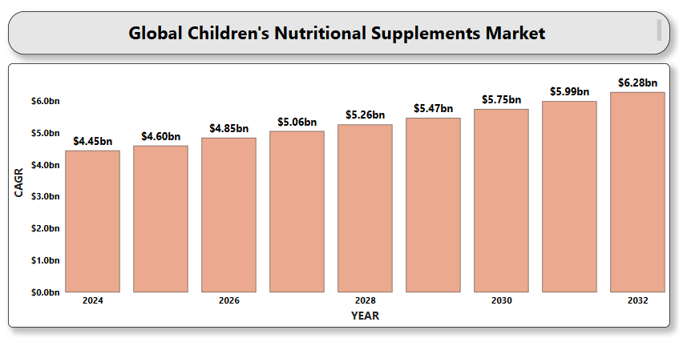

**Global Telemedicine for Pediatric Care Market**

**By Type of Service** (Tele-consultation, Tele-monitoring, Tele-diagnosis, Tele-pharmacy, Tele-education), **By Component** (Hardware, Software, Services), **By Delivery Mode** (Web-based Telemedicine, Cloud-based Telemedicine, On-premises Telemedicine), **By Application** (Chronic Disease Management, Emergency Care, Mental and Behavioral Health, Nutrition and Lifestyle Counseling, Post-operative Follow-up, Preventive and Routine Care), **By End User** (Homecare Settings, School-based Health Centers, Specialty Pediatric Centers, Telehealth Service Providers), **By Region** (North America, Europe, Asia-Pacific, Latin America, Middle East & Africa). Global and Regional Industry Overview, Market Intelligence, Comprehensive Analysis, Historical Data, and Forecasts 2024 – 2032.

According to Intelli, the Global Telemedicine for Pediatric Care Market size was valued at USD 35.1 Billion in 2024 and is projected to reach USD 224.18 Billion by 2032, growing at a CAGR of 26.58% during the forecast period 2024 to 2032.

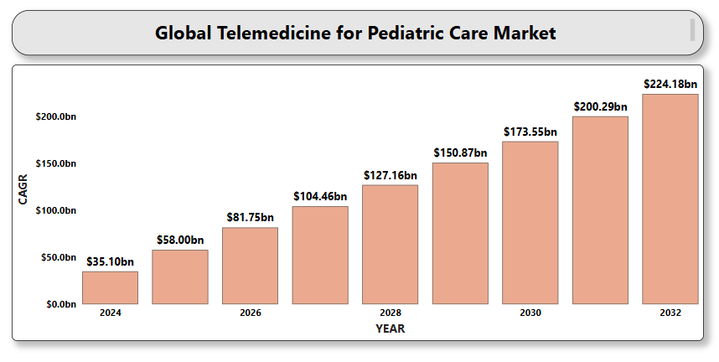

**Global Sun Protection and Skincare Products Market**

**By** **Product Type** (Sun Protection Products: Sunscreens, After-sun Products, Tanning Products; Skincare Products: Moisturizers, Anti-aging Creams, Serums, Face Masks, Cleansers and Toners, Exfoliators and Scrubs), **By SPF Range** (Below SPF 15, SPF 15–30, SPF 31–50, Above SPF 50), **By** **Formulation** (Creams & Lotions, Gels, Sprays, Sticks, Powders), **By** **Gender** (Male, Female), **By** **Distribution Channel** (Supermarkets/Hypermarkets, Pharmacies/Drug Stores, Online Retail, Beauty Salons & Spas, Convenience Stores, Specialty Stores), **By** **Region** (North America, Europe, Asia-Pacific, Latin America, Middle East & Africa). Global and Regional Industry Overview, Market Intelligence, Comprehensive Analysis, Historical Data, and Forecasts 2024 – 2032.

According to Intelli, the Global Sun Protection and Skincare Products Market size was valued at USD 14.45 Billion in 2024 and is projected to reach USD 20.90 Billion by 2032, growing at a CAGR of 5.22 % during the forecast period 2024 to 2032.

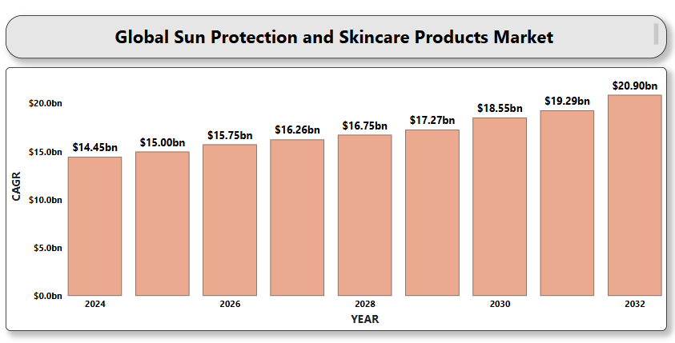

**Global AR/VR in Cosmetics Retail Market**

**By Application** (Virtual Try-On, AR Mirrors, Virtual Stores, AI Skin & Hair Diagnostics, 3D Product Displays), **By Technology** (Augmented Reality (AR), Virtual Reality (VR)), **By Offering** (Hardware, Software), **By Device Type** (Smart AR Mirrors, Head-Mounted Displays (HMDs), Handheld Devices), **By Region** (North America, Europe, Asia-Pacific, Latin America, Middle East & Africa). Global and Regional Industry Overview, Market Intelligence, Comprehensive Analysis, Historical Data, and Forecasts 2024 – 2032.

According to Intelli, the Global AR/VR in Cosmetics Retail Market size was valued at USD 5.26 Billion in 2024 and is projected to reach USD 37.25 Billion by 2032, growing at a CAGR of 28.22% during the forecast period 2024 to 2032.

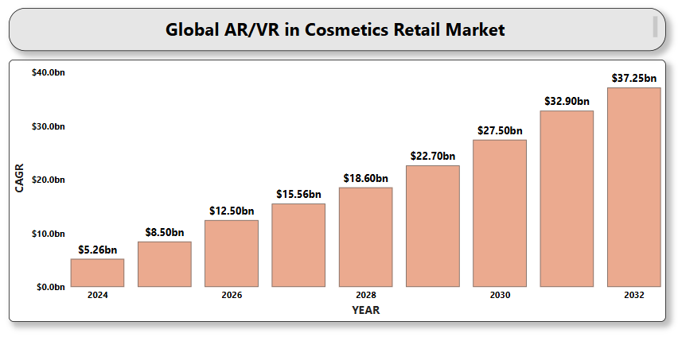

**Global Anti-Inflammatory Nutraceuticals Market**

**By Product Type** (Dietary Supplements, Functional Foods, Functional Beverages), **By** **Source** (Plant-Based, Animal-Based, Microbial-Based), **By** **Application** (Joint and Bone Health, Cardiovascular Health, Diabetes and Metabolic Disorders, Immune System Support, Neurological Health, Skin Health and Anti-Aging), **By Form** (Capsules and Tablets, Powders, Liquids, Softgels and Gummies, Teas and Drinks), **By** **Region** (North America, Europe, Asia-Pacific, Latin America, Middle East & Africa). Global and Regional Industry Overview, Market Intelligence, Comprehensive Analysis, Historical Data, and Forecasts 2024 – 2032.

According to Intelli, the Global Anti-Inflammatory Nutraceuticals Market size was valued at USD 8,693.96 Million in 2024 and is projected to reach USD 15,201.71 Million by 2032, growing at a CAGR of 7.73% during the forecast period 2024 to 2032.

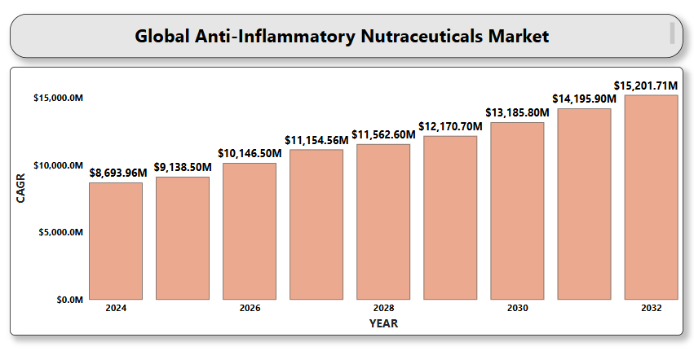

**Global Sports and Fitness Supplements Market**

**By Product Type** (Protein Supplements, Amino Acids and BCAAs, Vitamins and Minerals, Pre-Workout Supplements, Electrolytes and Hydration Products, Recovery Supplements), **By Form** (Powder, Capsules/Tablets, Ready-to-Drink (RTD) Beverages, Bars and Snacks), **By Application** (Bodybuilding and Muscle Growth, Endurance and Stamina Enhancement, Weight Management and Fat Loss, General Health and Wellness, Recovery and Injury Prevention), **By Distribution Channel** (Online Retail, Specialty Stores, Supermarkets and Hypermarkets, Pharmacies and Drugstores), **By End-User** (Professional Athletes, Fitness Enthusiasts, Recreational Users, Elderly Population), **By Region** (North America, Europe, Asia-Pacific, Latin America, Middle East & Africa). Global and Regional Industry Overview, Market Intelligence, Comprehensive Analysis, Historical Data, and Forecasts 2024 – 2032.

According to Intelli, the Global Sports and Fitness Supplements Market size was valued at USD 22,450.01 Million in 2024 and is projected to reach USD 33,920.3 Million by 2032, growing at a CAGR of 5.79% during the forecast period 2024 to 2032.

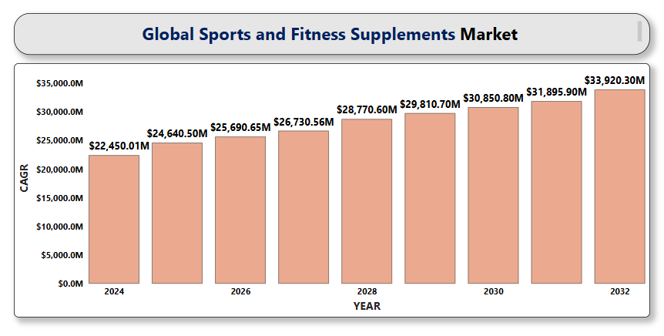

**Global Pet Nutraceuticals Market**

**By Product Type** (Dietary Supplements, Functional Foods, Medicinal Foods, Probiotics & Prebiotics, Herbal & Natural Products, Omega Fatty Acids, Vitamins & Minerals, Proteins & Amino Acids), **By Pet Type** (Dogs, Cats, Others), **By Application** (Joint Health, Digestive Health, Skin & Coat Health, Immune Support, Weight Management, Cognitive Function, Anxiety & Stress Relief, Overall Wellness / Preventive Care), **By Form** (Tablets & Capsules, Soft Chews, Powders, Liquids & Oils, Functional Treats, Sprays & Pastes), **By Distribution Channel** (Veterinary Clinics, Pet Specialty Stores, Online Retail / E-commerce, Supermarkets & Hypermarkets, Pharmacies / Drug Stores), **By Region** (North America, Europe, Asia-Pacific, Latin America, Middle East & Africa). Global and Regional Industry Overview, Market Intelligence, Comprehensive Analysis, Historical Data, and Forecasts 2024 – 2032.

According to Intelli, the Global Pet Nutraceuticals Market size was valued at USD 6.8 Billion in 2024 and is projected to reach USD 10.7 Billion by 2032, growing at a CAGR of 6.36% during the forecast period 2024 to 2032.

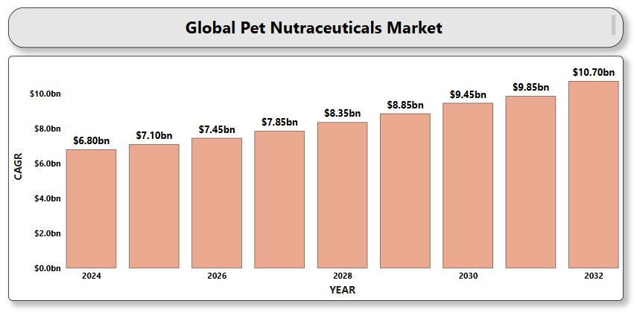

**Global Anti-Stress and Relaxation Supplements Market**

**By Product Type** (Capsules & Tablets, Powders, Gummies, Teas & Infusions, Functional Beverages, Others), **By Ingredient Type** (Adaptogens, Herbal Extracts, Amino Acids, Vitamins & Minerals, Combination Formulas), **By End User** (Adults, Geriatric Population, Teenagers & Young Adults), **By Distribution Channel** (Pharmacies & Drug Stores, Online Retail/E-commerce, Supermarkets/Hypermarkets, Health & Wellness Stores), **By Region** (North America, Europe, Asia-Pacific, Latin America, Middle East & Africa). Global and Regional Industry Overview, Market Intelligence, Comprehensive Analysis, Historical Data, and Forecasts 2024 – 2032.

According to Intelli, the Global Anti-Stress and Relaxation Supplements Market size was valued at USD 602.35 Million in 2024 and is projected to reach USD 942.4 Million by 2032, growing at a CAGR of 6.25% during the forecast period 2024 to 2032.

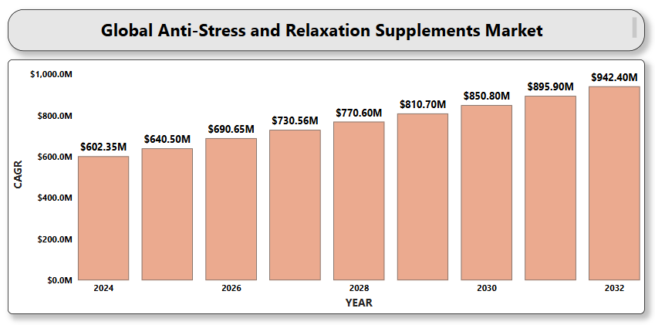

**Global Nutraceuticals for Pregnancy and Lactation Market**

**By Product Type** (Vitamins and Minerals, Omega-3 Fatty Acids, Probiotics, Herbal Supplements, Protein and Amino Acid Supplements), **By Formulation** (Tablets and Capsules, Powder, Liquid/Syrups, Gummies and Chewables, Others), **By Distribution Channel** (Pharmacies and Drug Stores, Supermarkets and Hypermarkets, Online Retail/E-commerce, Specialty Stores, Hospitals and Clinics), **By Region** (North America, Europe, Asia-Pacific, Latin America, Middle East & Africa). Global and Regional Industry Overview, Market Intelligence, Comprehensive Analysis, Historical Data, and Forecasts 2024 – 2032.

According to Intelli, the Global Nutraceuticals for Pregnancy and Lactation Market size was valued at USD 650.06 Million in 2024 and is projected to reach USD 1,136.65 Million by 2032, growing at a CAGR of 7.73% during the forecast period 2024 to 2032.

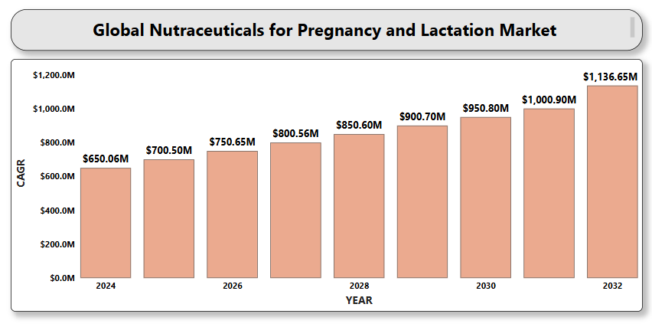

**Global Hydration and Electrolyte Supplements Market**

**By Product Type** (Powders, Ready-to-Drink (RTD) Beverages, Tablets & Capsules, Others), **By Electrolyte Content** (Sodium-Based Supplements, Potassium-Based Supplements, Calcium-Based Supplements, Magnesium-Based Supplements, Multi-Electrolyte Blends), **By End User** (Athletes & Fitness Enthusiasts, Medical & Clinical Patients, Industrial & Outdoor Workers, General Consumers), **By Distribution Channel** (Pharmacies & Drug Stores, Online Retail/E-commerce, Supermarkets & Hypermarkets, Specialty Stores & Health Stores), **By Region** (North America, Europe, Asia-Pacific, Latin America, Middle East & Africa). Global and Regional Industry Overview, Market Intelligence, Comprehensive Analysis, Historical Data, and Forecasts 2024 – 2032.

According to Intelli, the Global Hydration and Electrolyte Supplements Market size was valued at USD 34.92 Billion in 2024 and is projected to reach USD 54.75 Billion by 2032, growing at a CAGR of 6.28% during the forecast period 2024 to 2032.

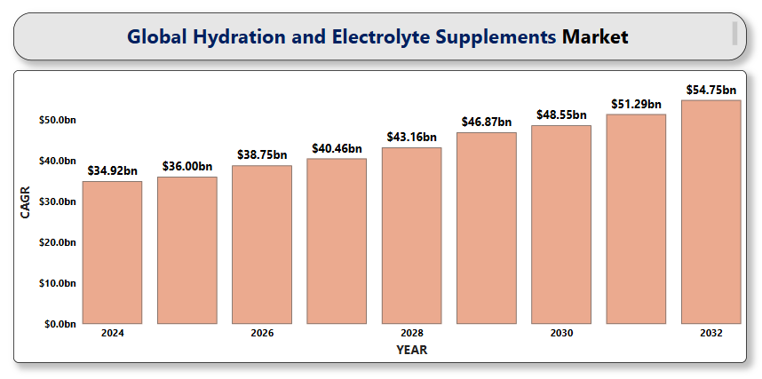

**Global Functional Oils and Fats Market**

**By Product Type** (Functional Oils: Fish Oil, Flaxseed Oil, Soybean Oil, Canola Oil, Olive Oil, Coconut Oil; Functional Fats: Butter, Margarine, Shortenings, Lard, Specialty Fats), **By Source** (Plant-based Oils and Fats, Animal-based Oils and Fats, Marine-based Oils), **By Application** (Food and Beverages, Dietary Supplements, Pharmaceuticals, Animal Nutrition, Personal Care and Cosmetics), **By Distribution Channel** (Supermarkets/Hypermarkets, Specialty Stores, Pharmacies and Health Stores, Online Retail, Direct Sales), **By Region** (North America, Europe, Asia-Pacific, Latin America, Middle East & Africa). Global and Regional Industry Overview, Market Intelligence, Comprehensive Analysis, Historical Data, and Forecasts 2024 – 2032.

According to Intelli, the Global Functional Oils and Fats Market size was valued at USD 12.48 Billion in 2024 and is projected to reach USD 18.09 Billion by 2032, growing at a CAGR of 5.25% during the forecast period 2024 to 2032.

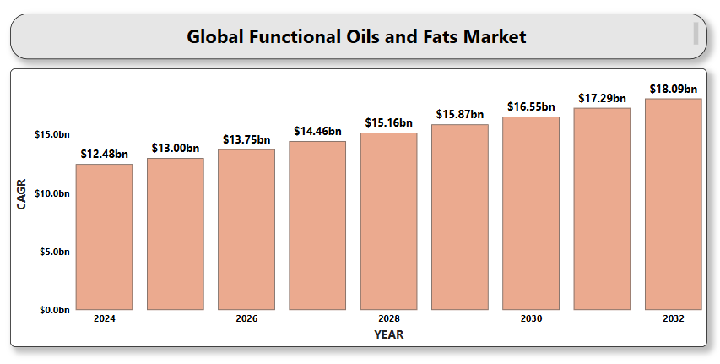

**Global Energy and Vitality Supplements Market**

**By Product Type** (Vitamins & Minerals, Herbal Supplements, Amino Acids, Enzymes & Coenzymes, Caffeine-Based Supplements, Adaptogens & Nootropics), **By Form** (Tablets & Capsules, Powders, Liquids, Soft Gels, Gummies, Effervescent Tablets, Energy Shots & Drinks), **By Distribution Channel** (Pharmacies/Drug Stores, Supermarkets/Hypermarkets, Specialty Health Stores, Online Retail/E-commerce, Direct Sales, Convenience Stores), **By Region** (North America, Europe, Asia-Pacific, Latin America, Middle East & Africa). Global and Regional Industry Overview, Market Intelligence, Comprehensive Analysis, Historical Data, and Forecasts 2024 – 2032.

According to Intelli, Global Energy and Vitality Supplements Market size was valued at USD 44 Billion in 2024 and is projected to reach USD 60.93 Billion by 2032, growing at a CAGR of 4.65% during the forecast period 2024 to 2032.

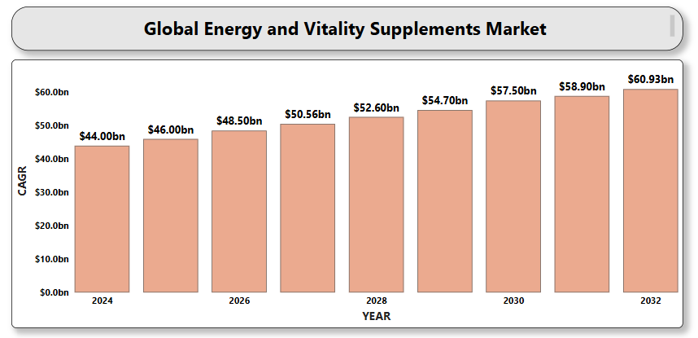

**Global Heart Health Nutraceuticals Market**

**By Product Type** (Functional Foods, Dietary Supplements, Beverages, Others) **By Ingredient Type** (Omega-3 Fatty Acids (EPA/DHA), Plant Sterols and Stanols, Antioxidants (e.g., polyphenols, flavonoids, resveratrol), Coenzyme Q10 (CoQ10), Soluble Fibers (e.g., beta-glucans), L-Carnitine, Magnesium and Potassium, Vitamins (e.g., B-complex, D, E)) **By Form** (Capsules and Tablets, Powders, Liquids, Softgels, Gummies) **By Distribution Channel** (Pharmacies and Drug Stores, Supermarkets and Hypermarkets, Online Retail (E-commerce), Direct Sales, Health & Wellness Stores) **By Region** (North America, Europe, Asia-Pacific, Latin America, Middle East & Africa). Global and Regional Industry Overview, Market Intelligence, Comprehensive Analysis, Historical Data, and Forecasts 2024 – 2032.

According to Intelli, the Global Heart Health Nutraceuticals Market size was valued at USD 10.25 Billion in 2024 and is projected to reach USD 24.44 Billion by 2032, growing at a CAGR of 8.14% during the forecast period 2024 to 2032.

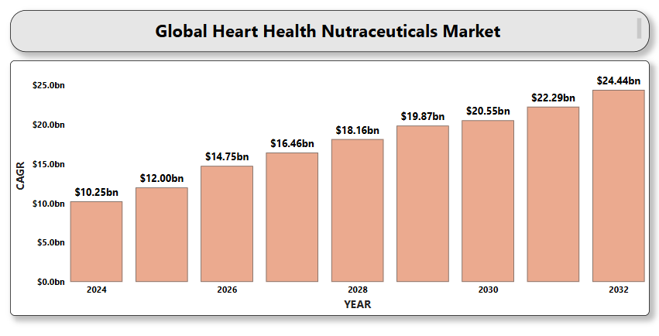

**Global Omega-3 Fatty Acids Market**

**By Source** (Marine Sources, Plant-Based Sources, Algal Oil), **By Type** (Eicosapentaenoic Acid (EPA), Docosahexaenoic Acid (DHA), Alpha-Linolenic Acid (ALA)), **By Application** (Dietary Supplements, Pharmaceuticals, Functional Foods & Beverages, Infant Formula, Animal Feed & Pet Nutrition), **By Distribution Channel** (Retail Pharmacies, Online Channels, Supermarkets/Hypermarkets, Health & Specialty Stores), **By Region** (North America, Europe, Asia-Pacific, Latin America, Middle East & Africa). Global and Regional Industry Overview, Market Intelligence, Comprehensive Analysis, Historical Data, and Forecasts 2024 – 2032.

According to Intelli, the Global Omega-3 Fatty Acids Market size was valued at USD 3.65 Billion in 2024 and is projected to reach USD 6.71 Billion by 2032, growing at a CAGR of 8.42% during the forecast period 2024 to 2032.

